**INTEGRATION TESTING:**

**Integration testing is the second level of the software testing process after unit testing. In this testing, units or individual components of the software are tested in a group. The focus of the integration testing level is to expose defects at the time of interaction between integrated components or units.**

**TESTING ALL FUNCTIONALITIES**

**User Interface:**

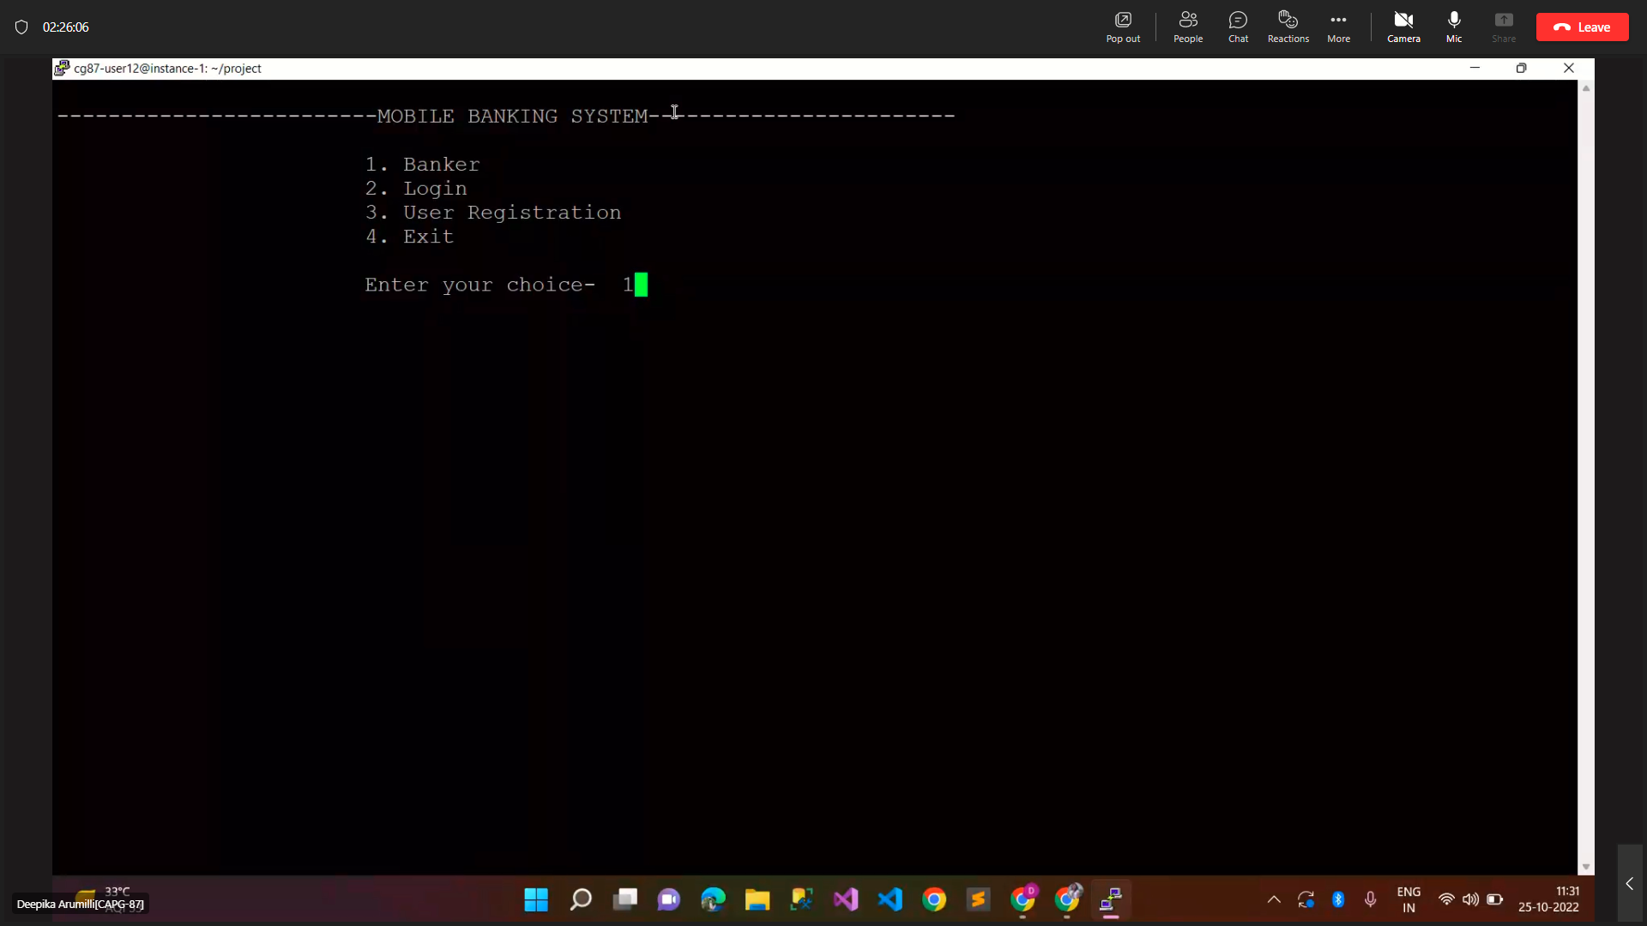

1. **BANKER MANAGEMENT FUNCTION**

**Sunny Testing Reports:-**

**test_case-01->banker_add_details _of_user**

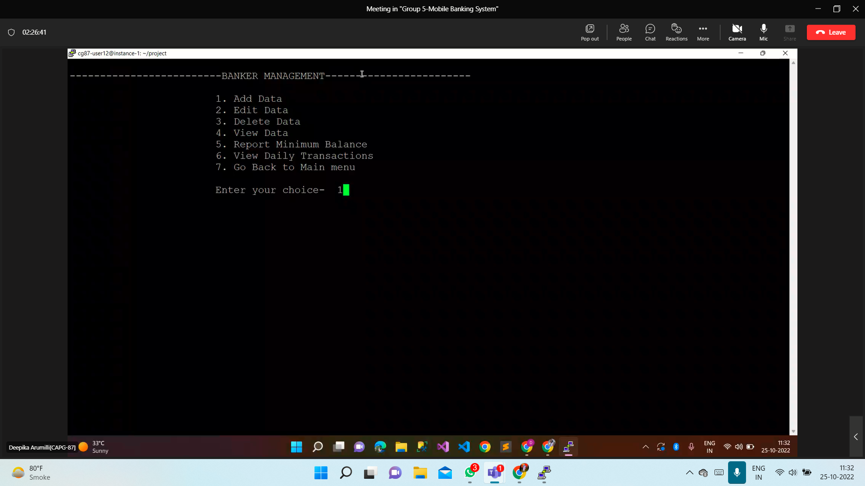

**Output:**

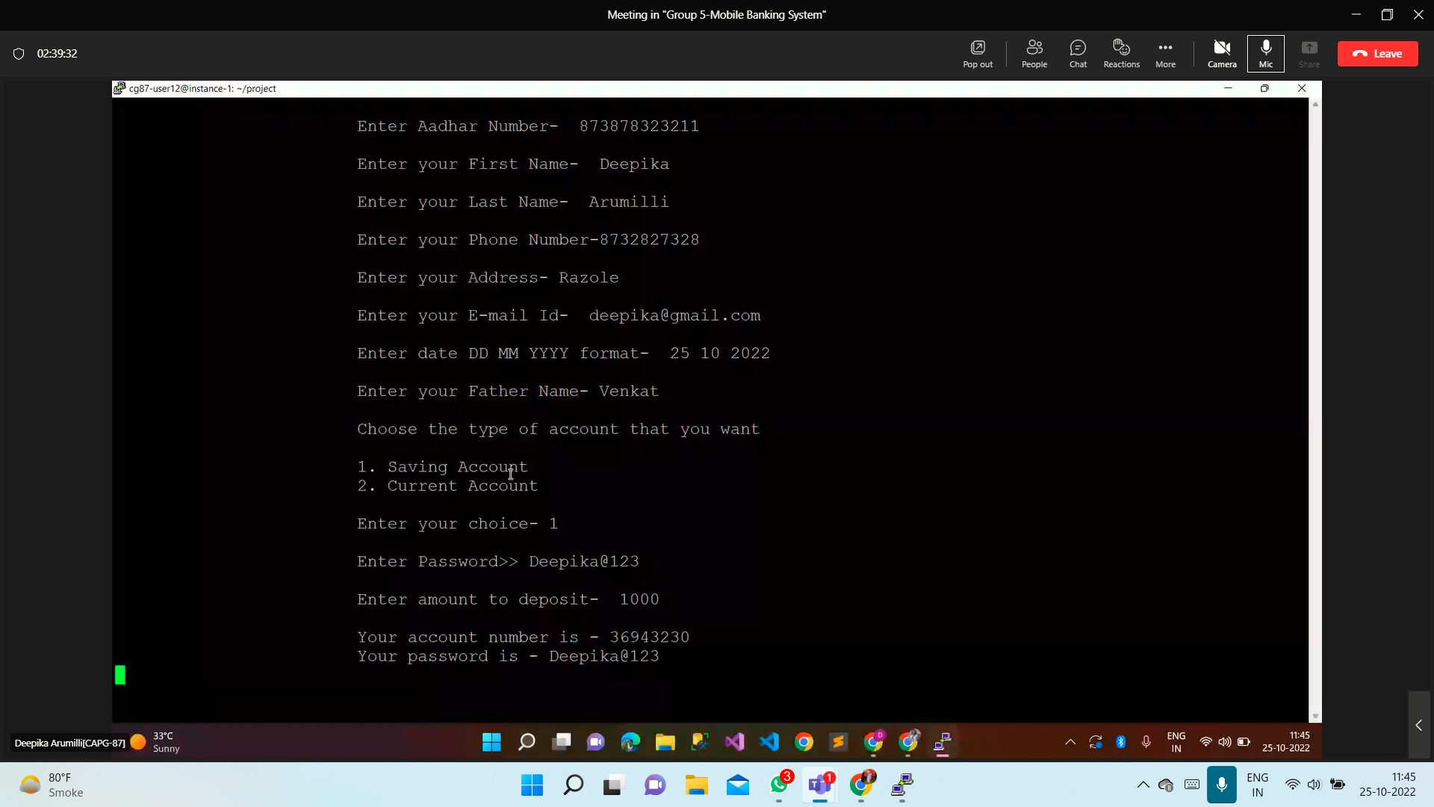

**test_case-02->banker_edit_details_of_user**

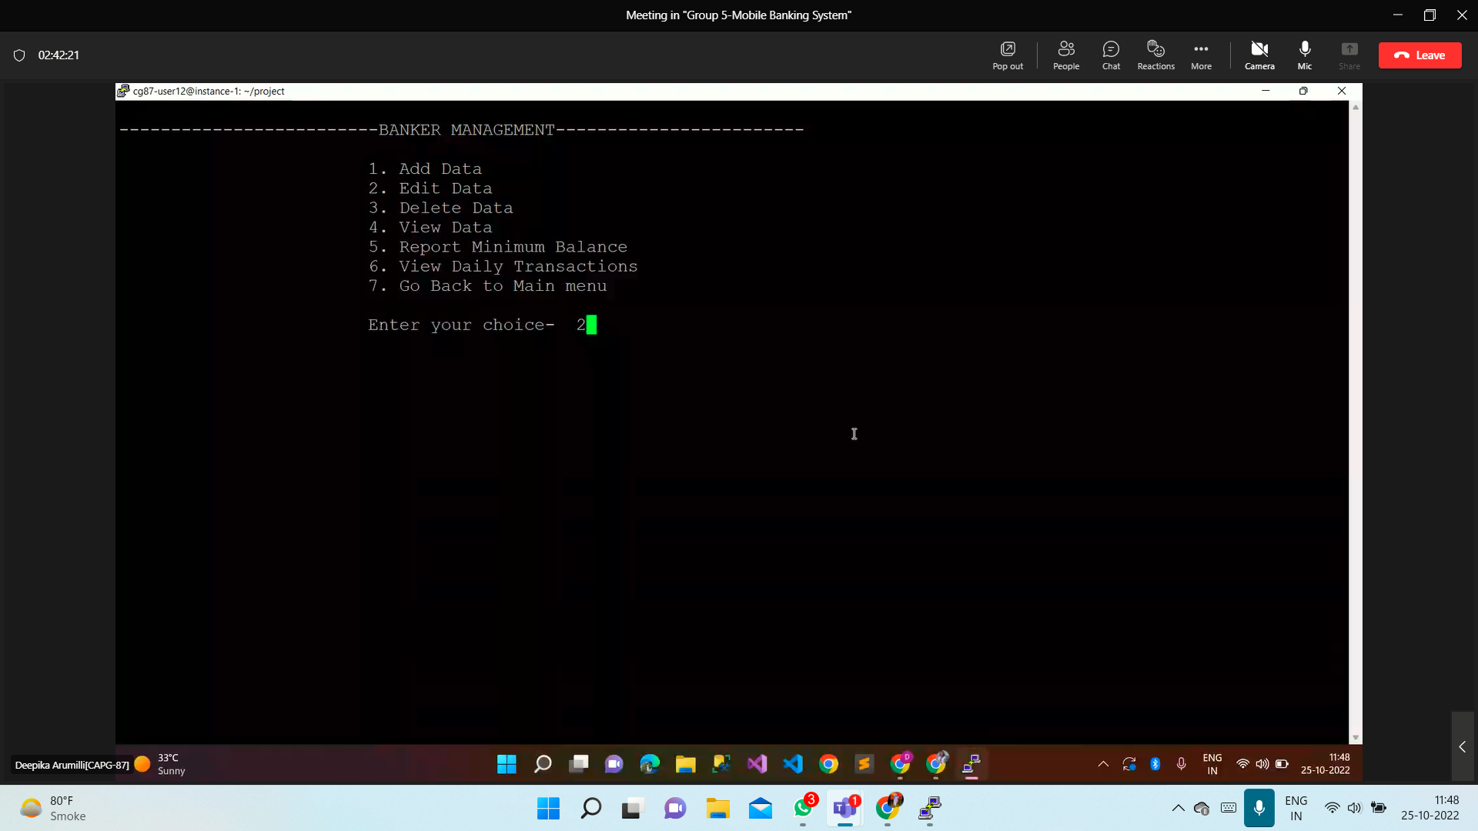

**Output:**

(A)

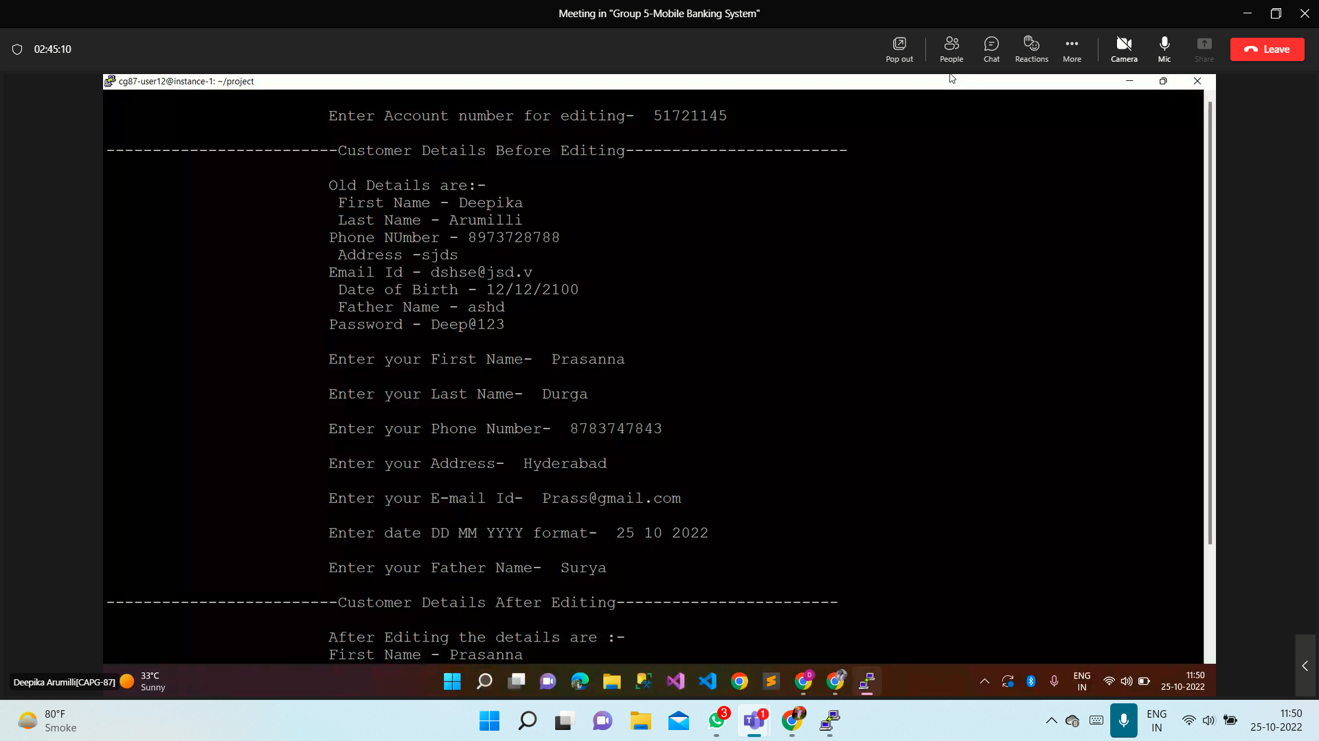

(B)

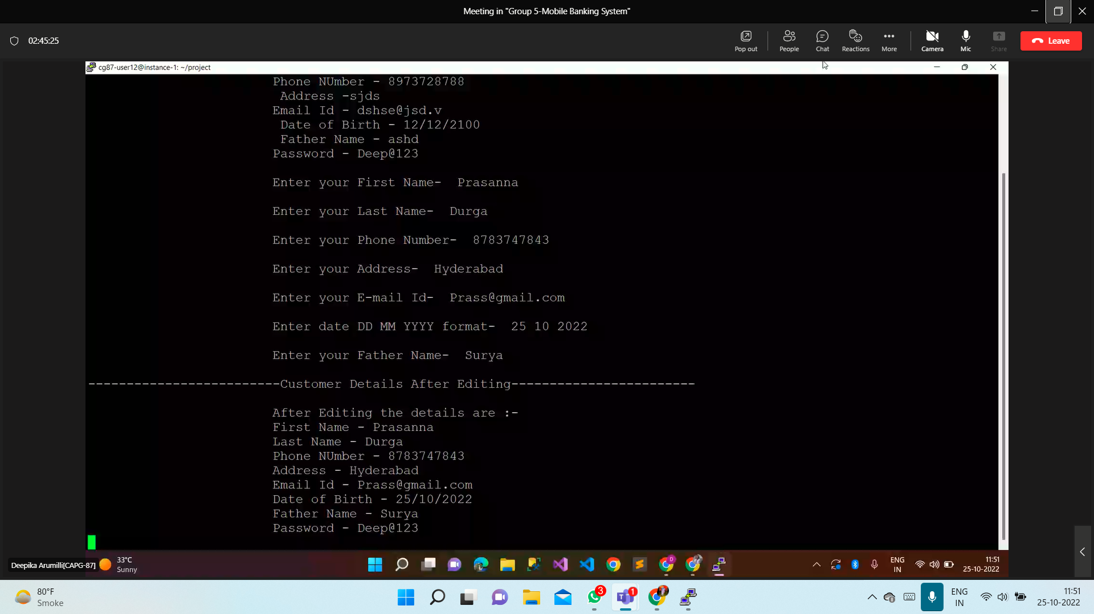

**test_case-03->banker_delete_data_of_user**

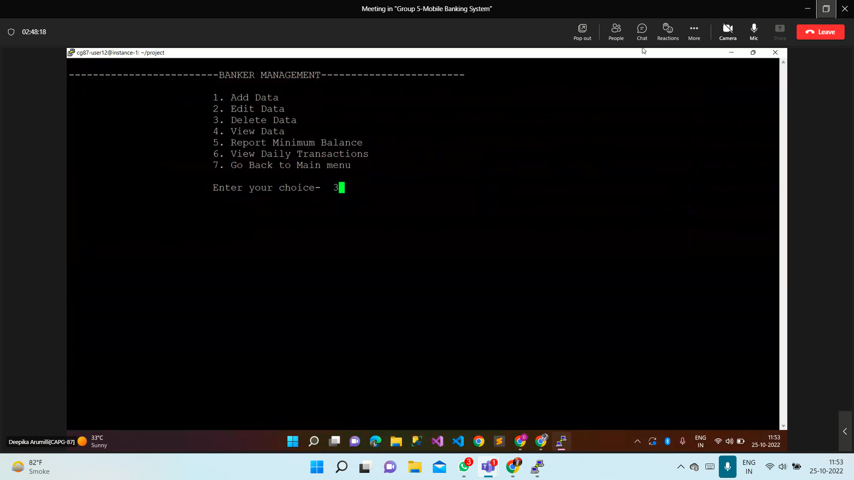

**Output:**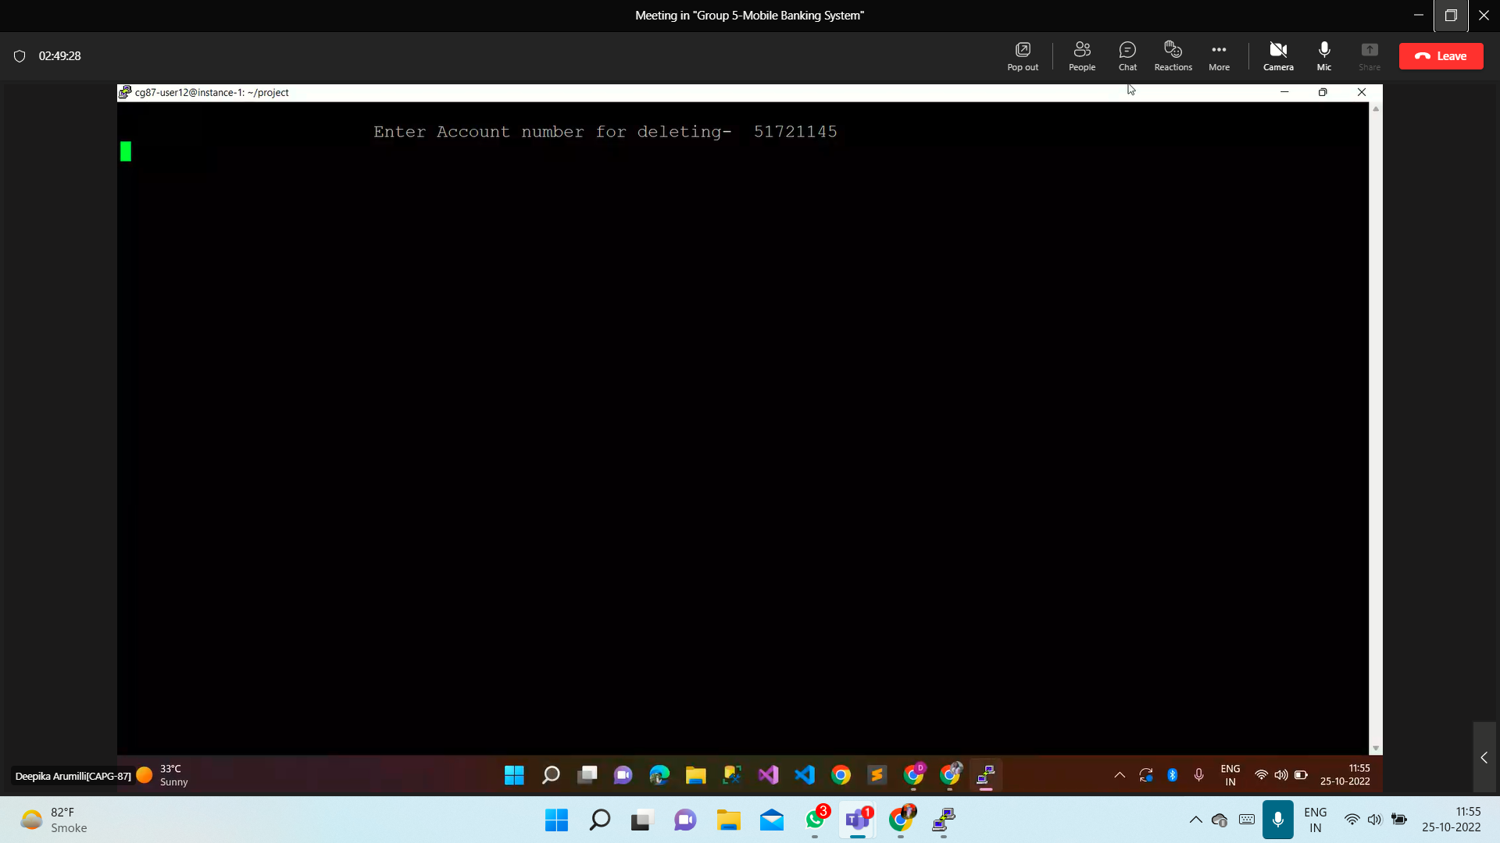

**test_case-04->banker_can_view_data_of_users**

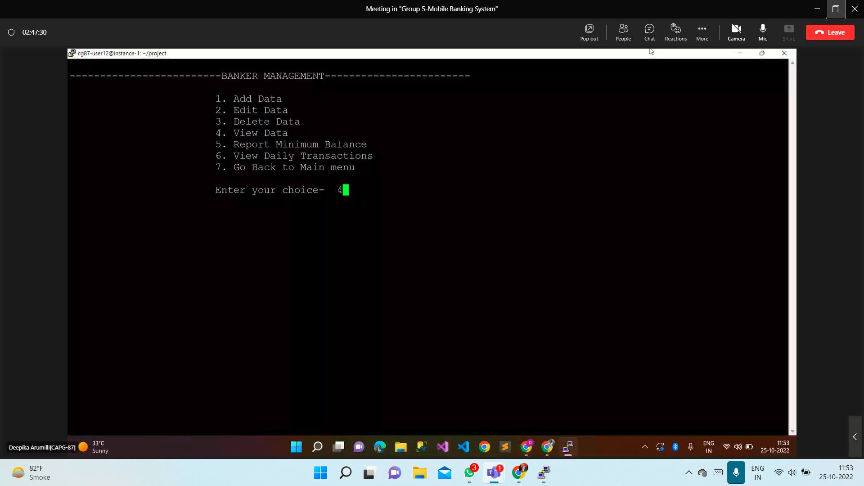

**Output:**

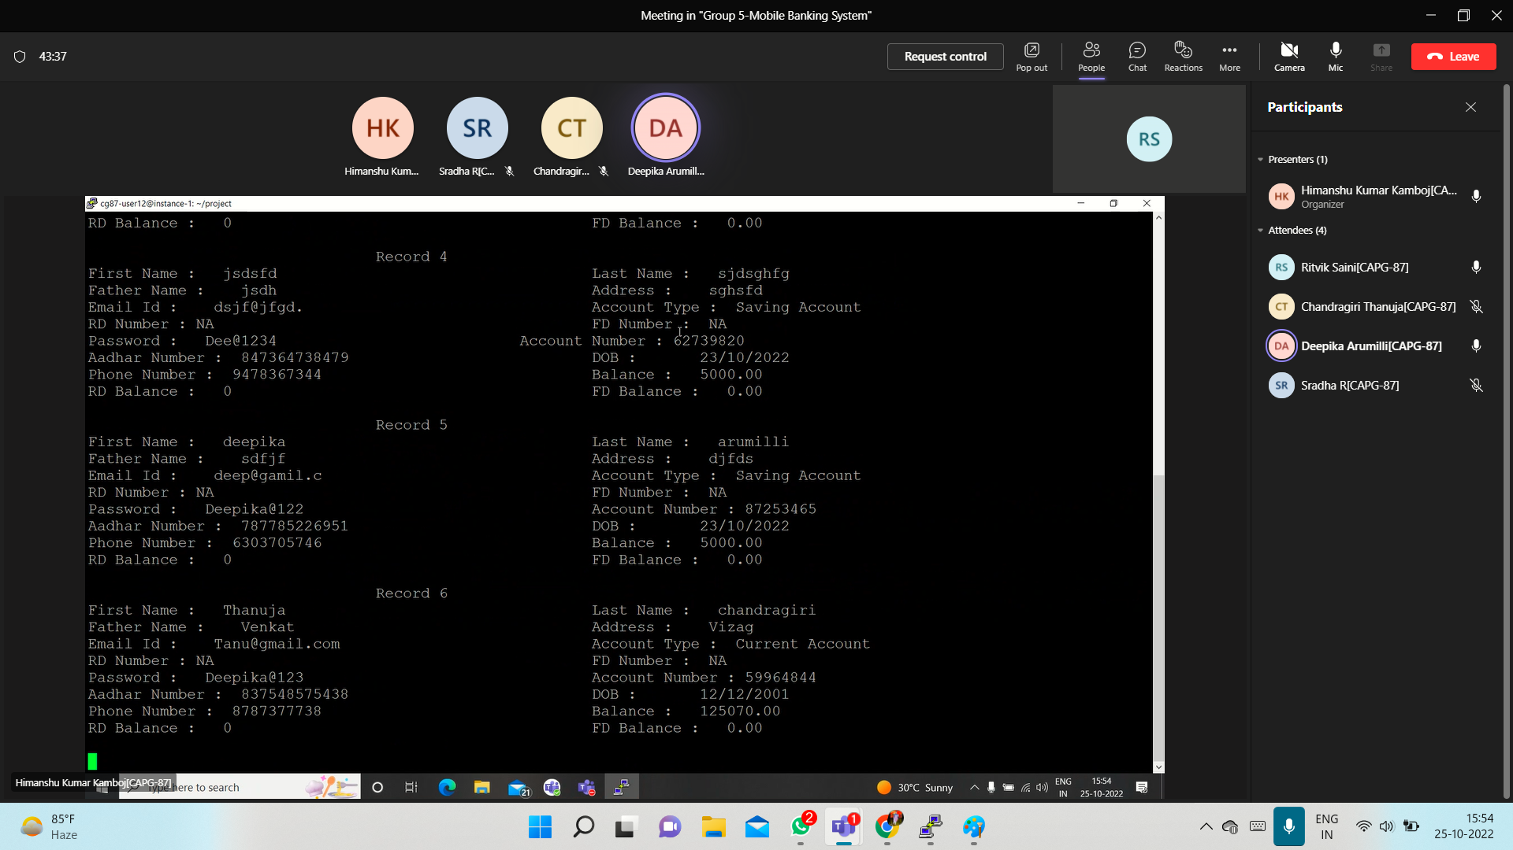

**test_case-05->generate_remainder_for_low_balance_account**

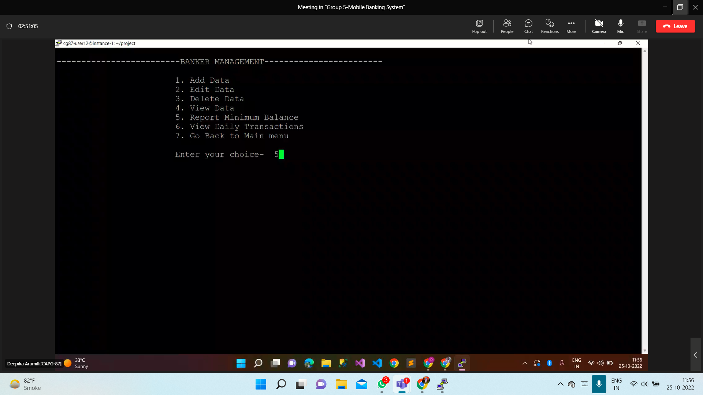

**Output:**

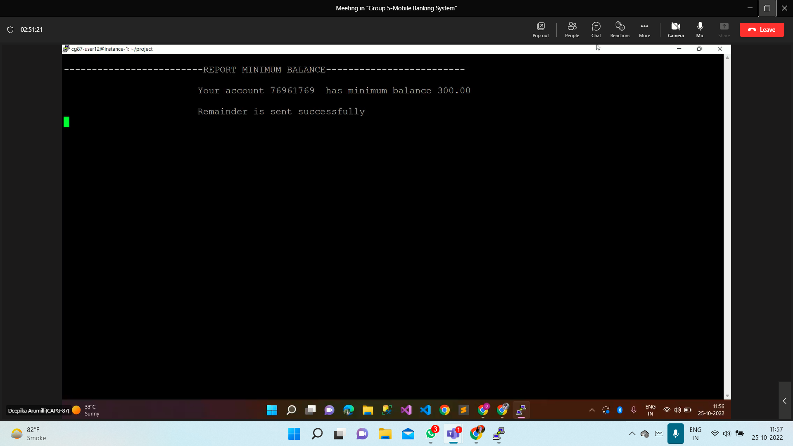

**test_case-06->banker_can_see_all_transaction**

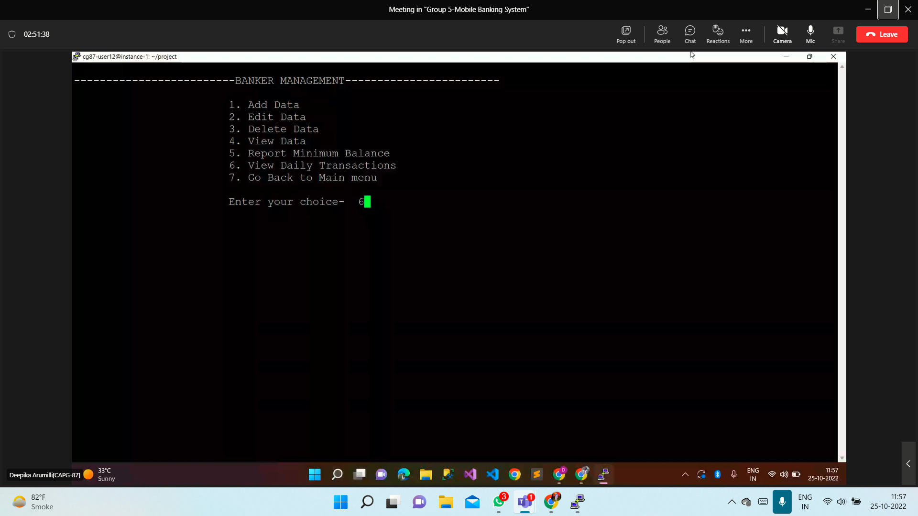

**Output:**

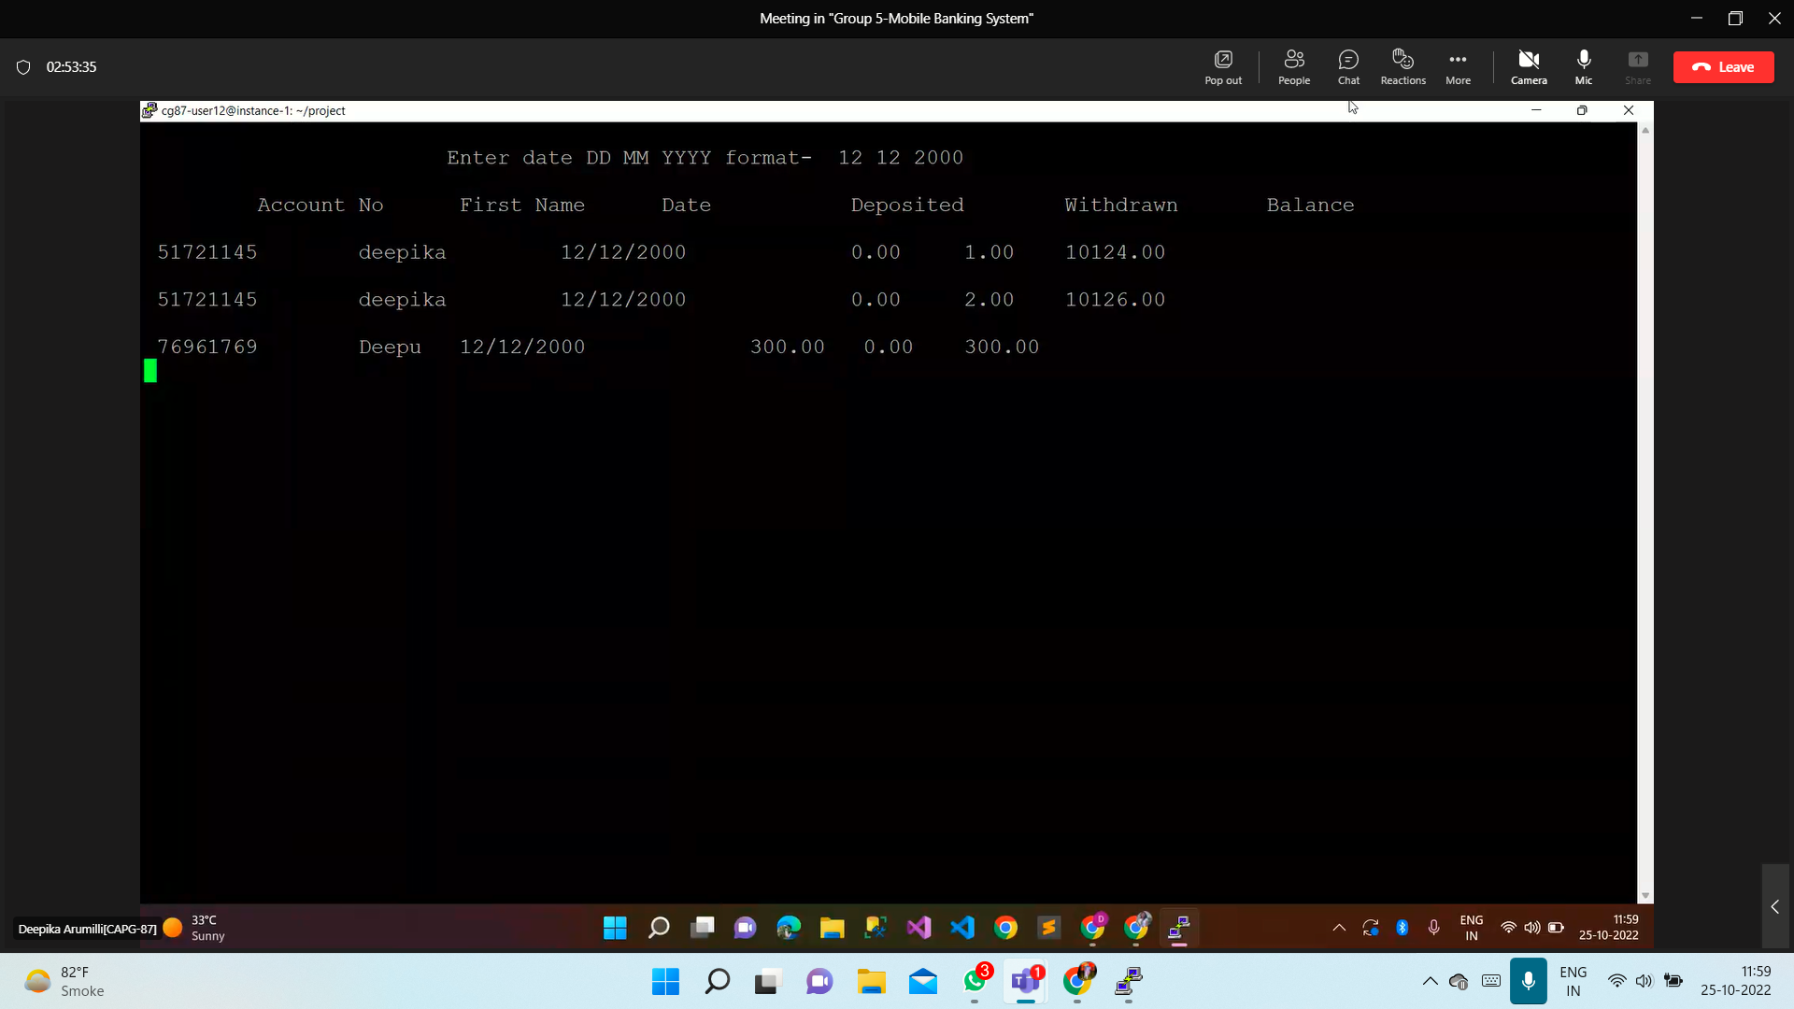

**Choice 7:**

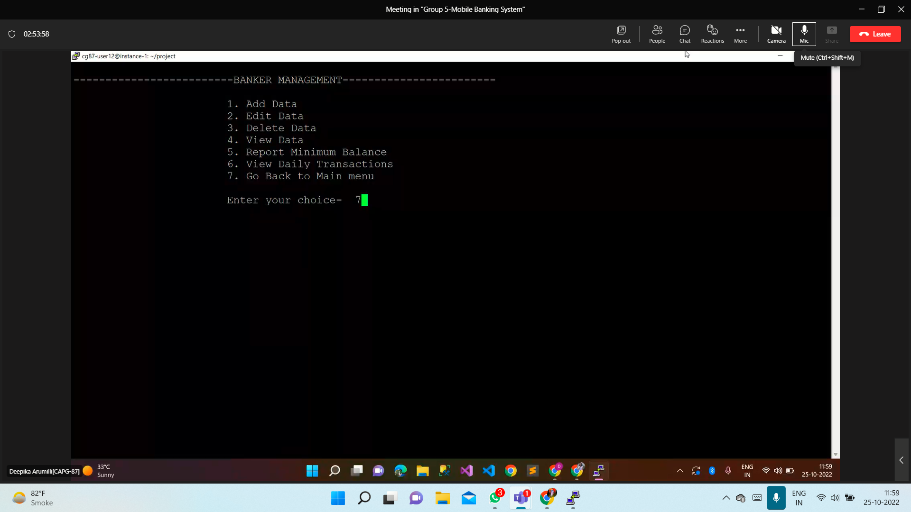

**(B)LOGIN**

**test_case-07->user_login**

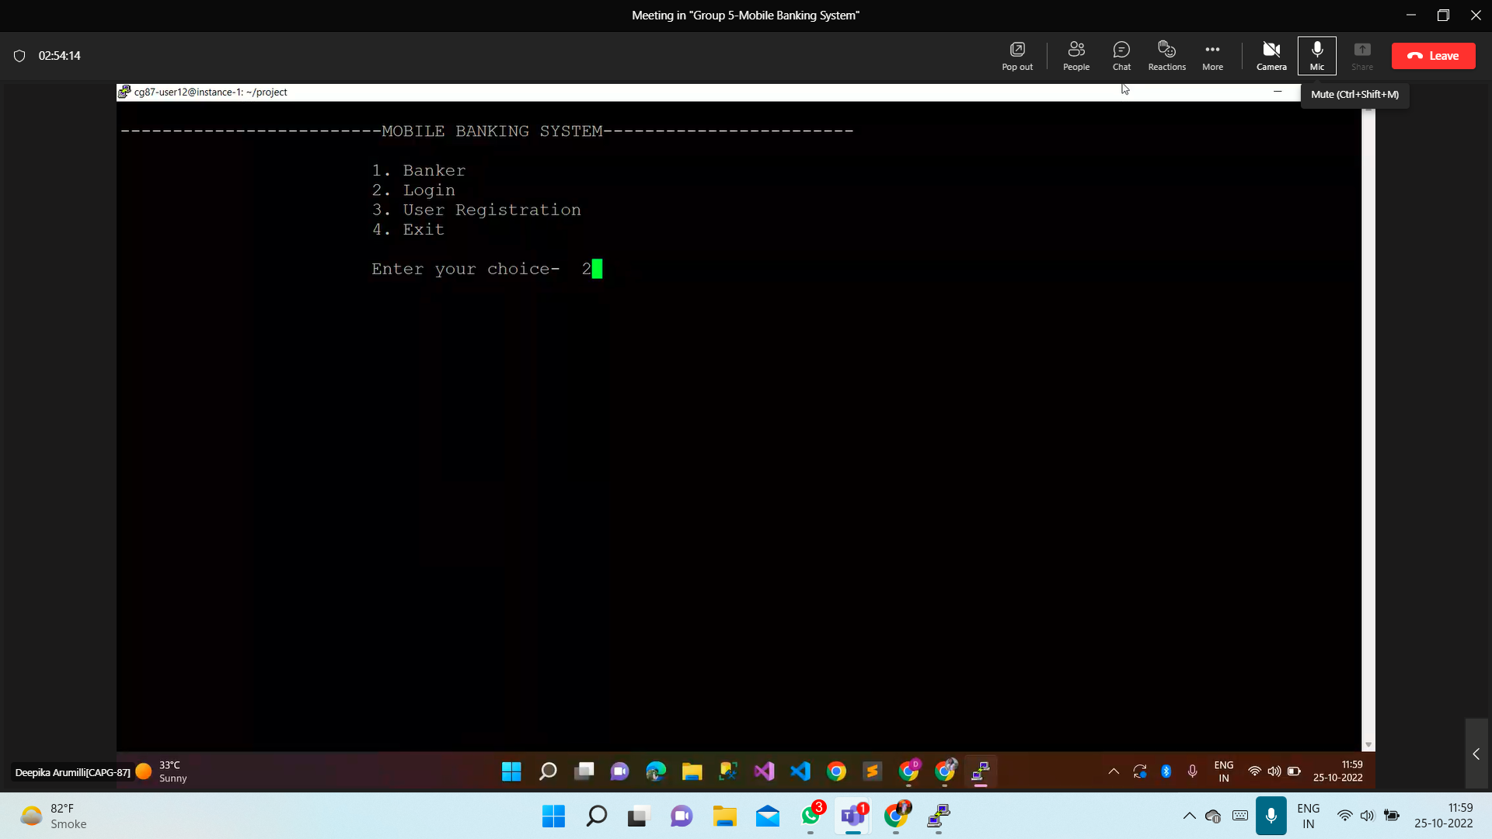

**Output:**

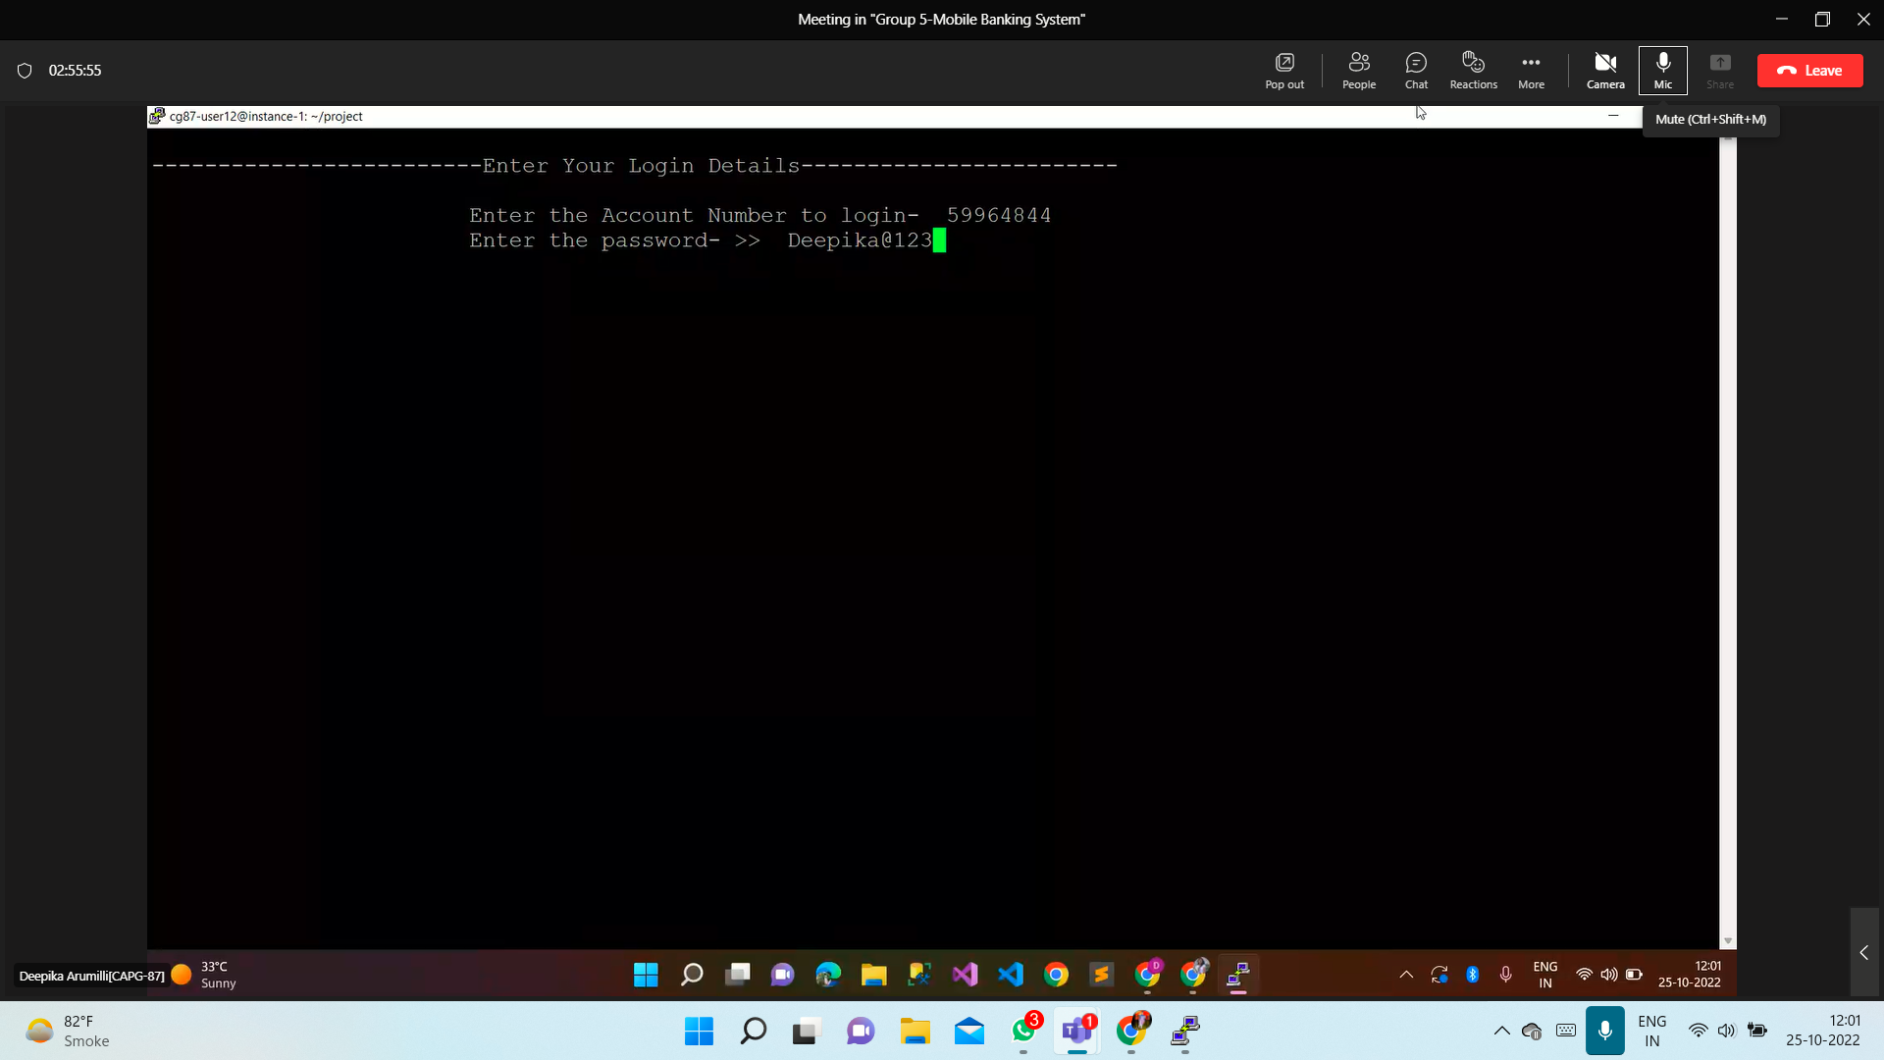

**test_case-08->user_can_view_account**

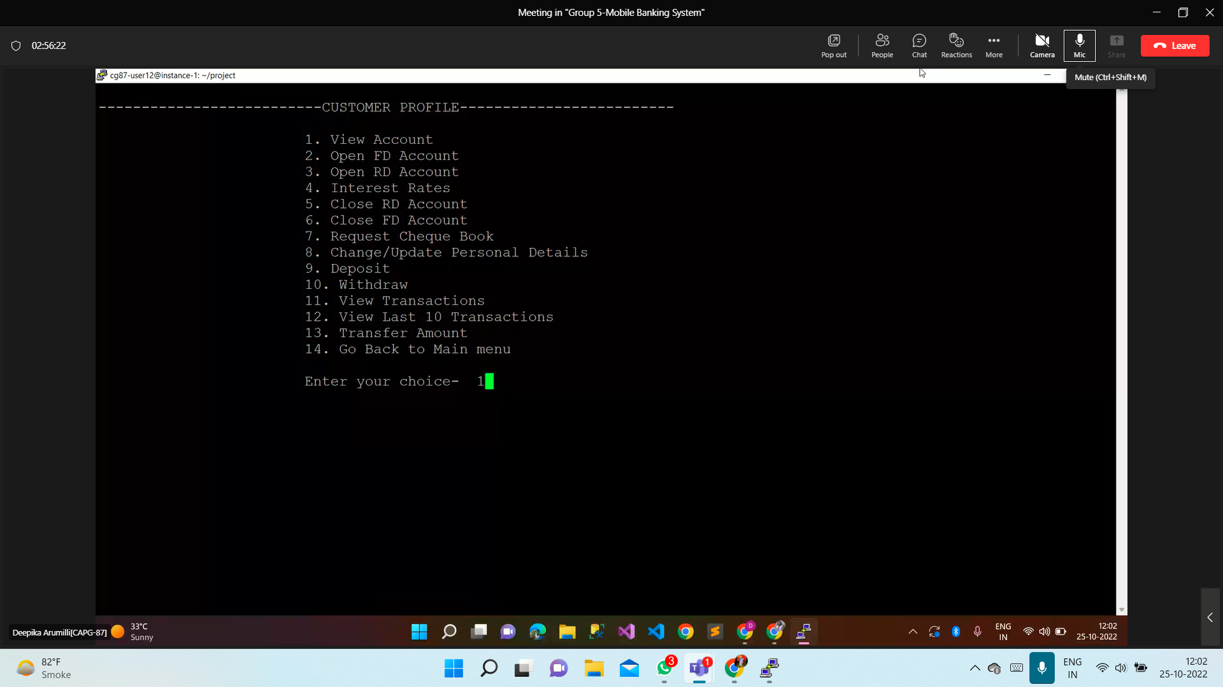

**Output:**

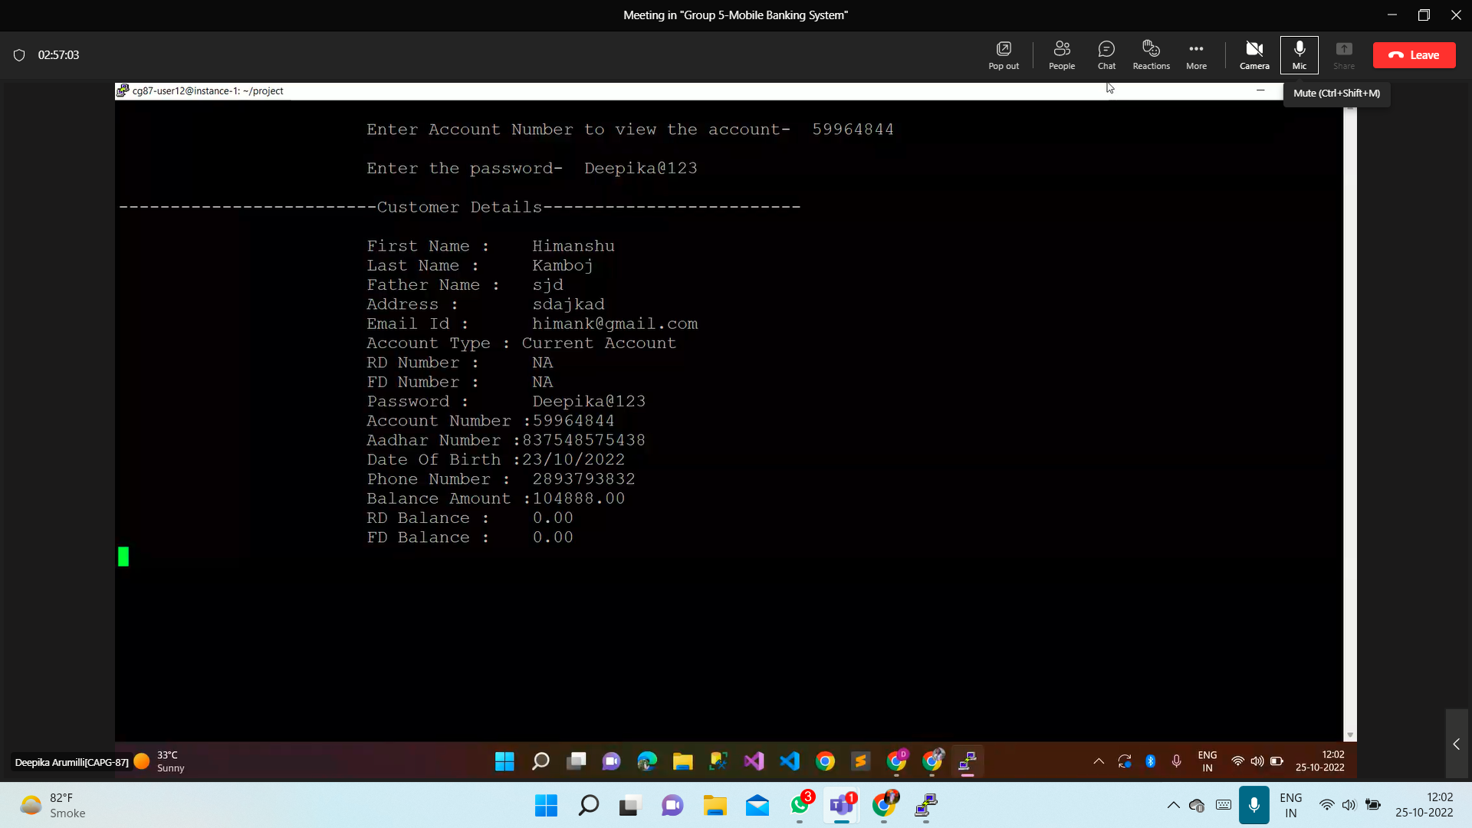

**test_case-09->user_open_fd_account**

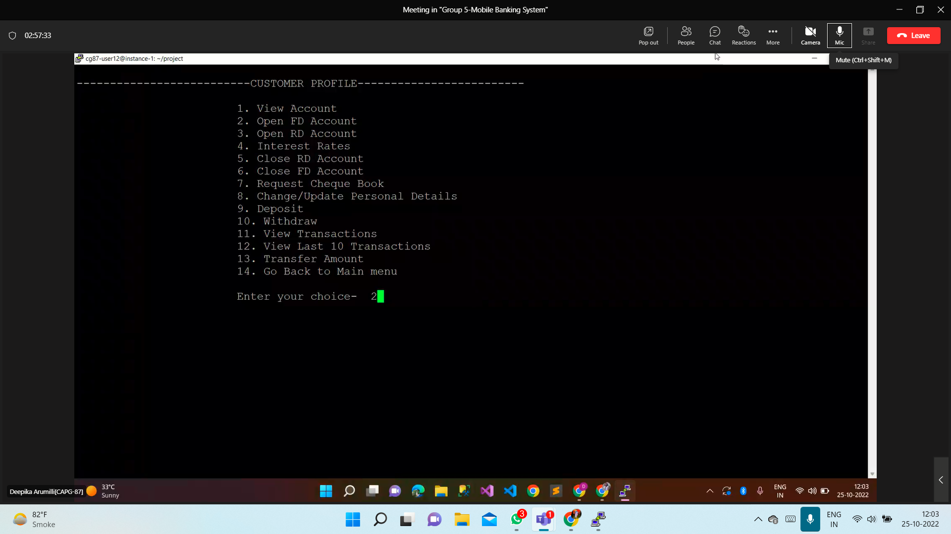

**Output:**

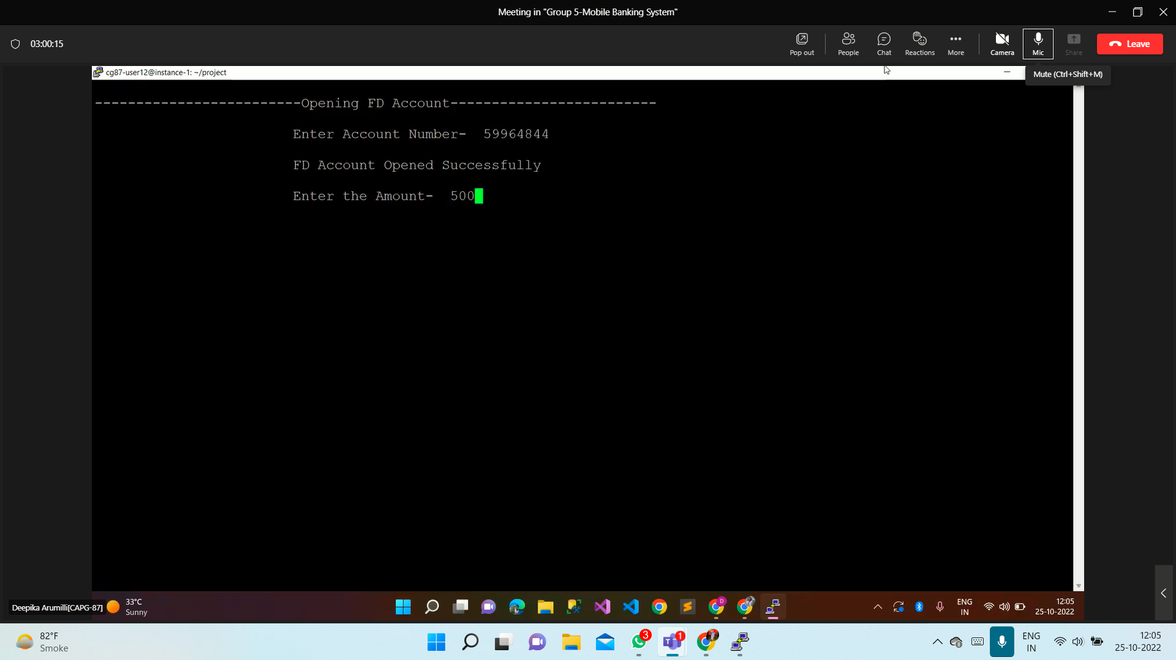

**test_case-10->user_open_rd_account**

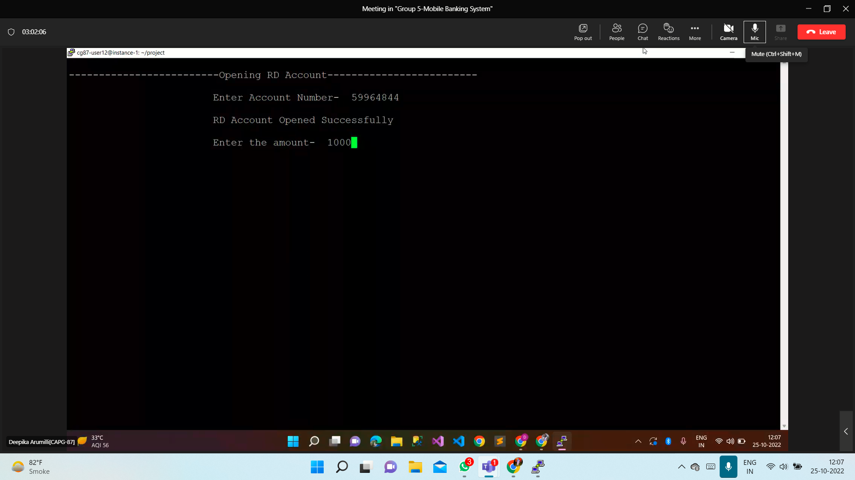

**Output of 9,10**

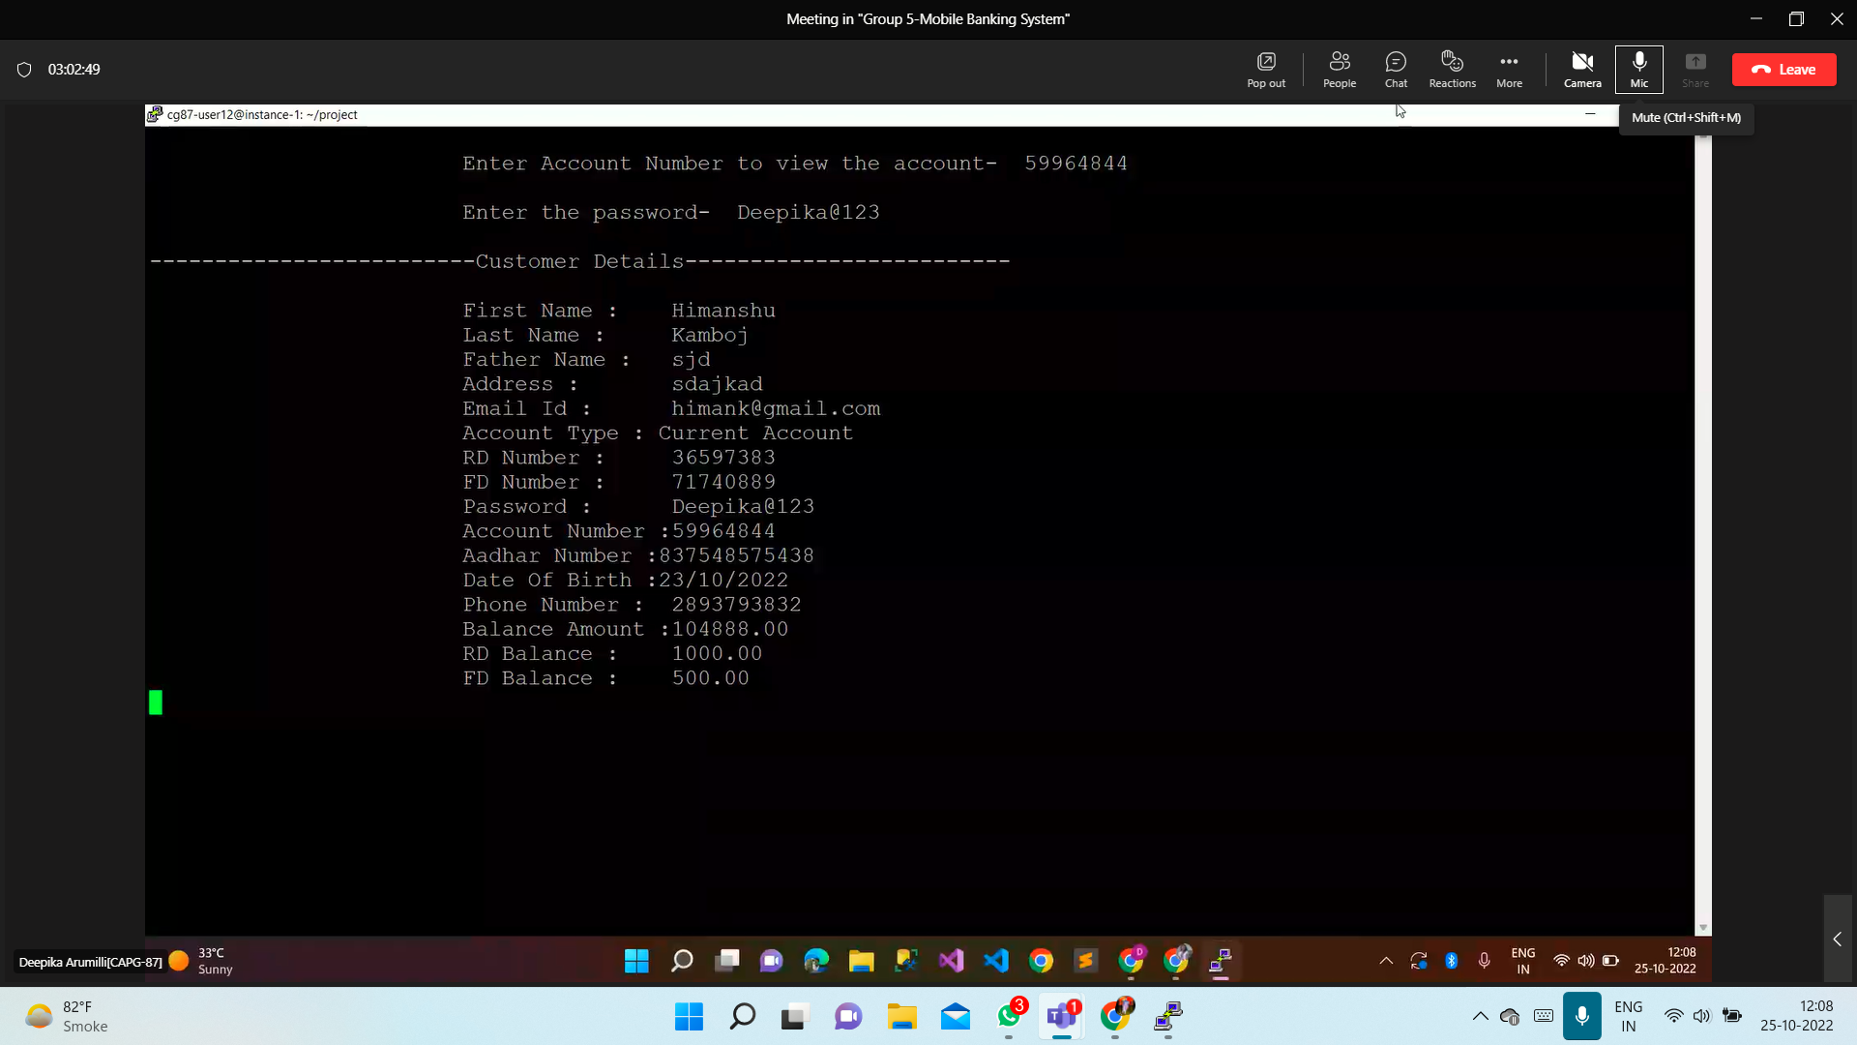

**test_case-11->interest_rates**

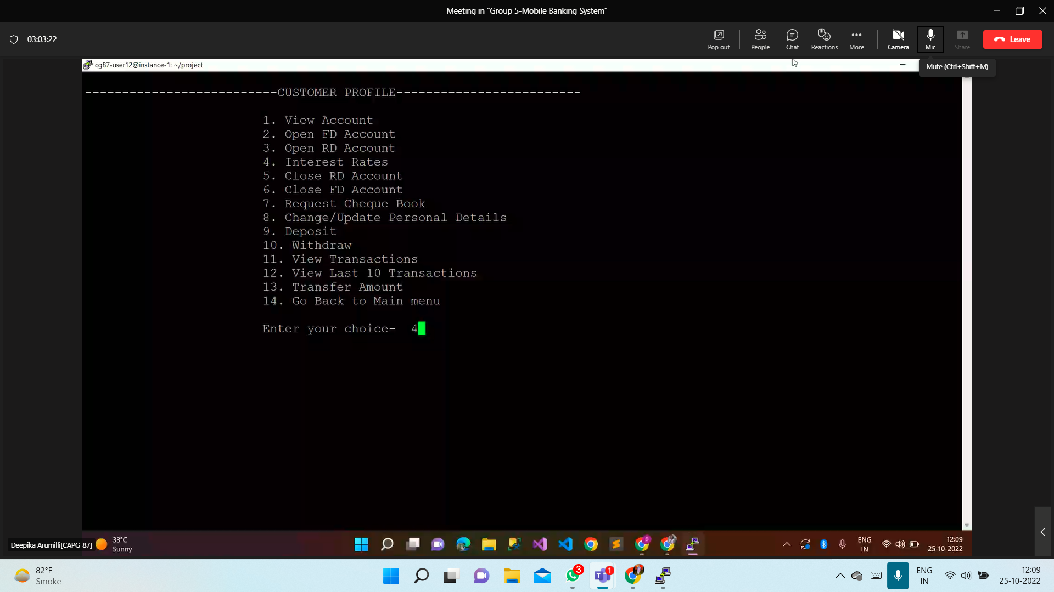

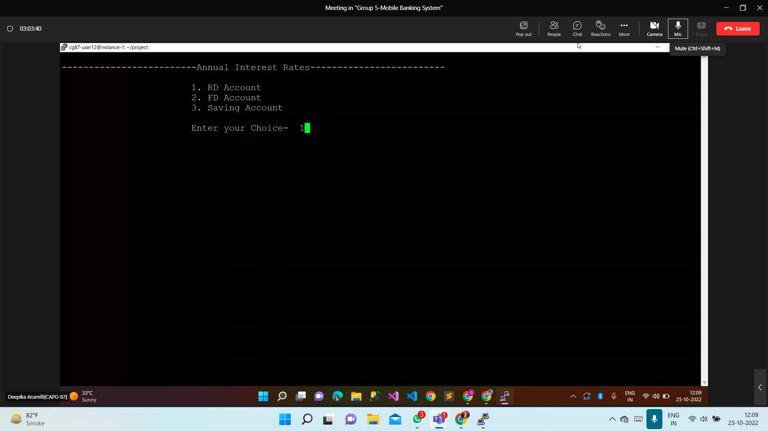

**Choice4.1:**

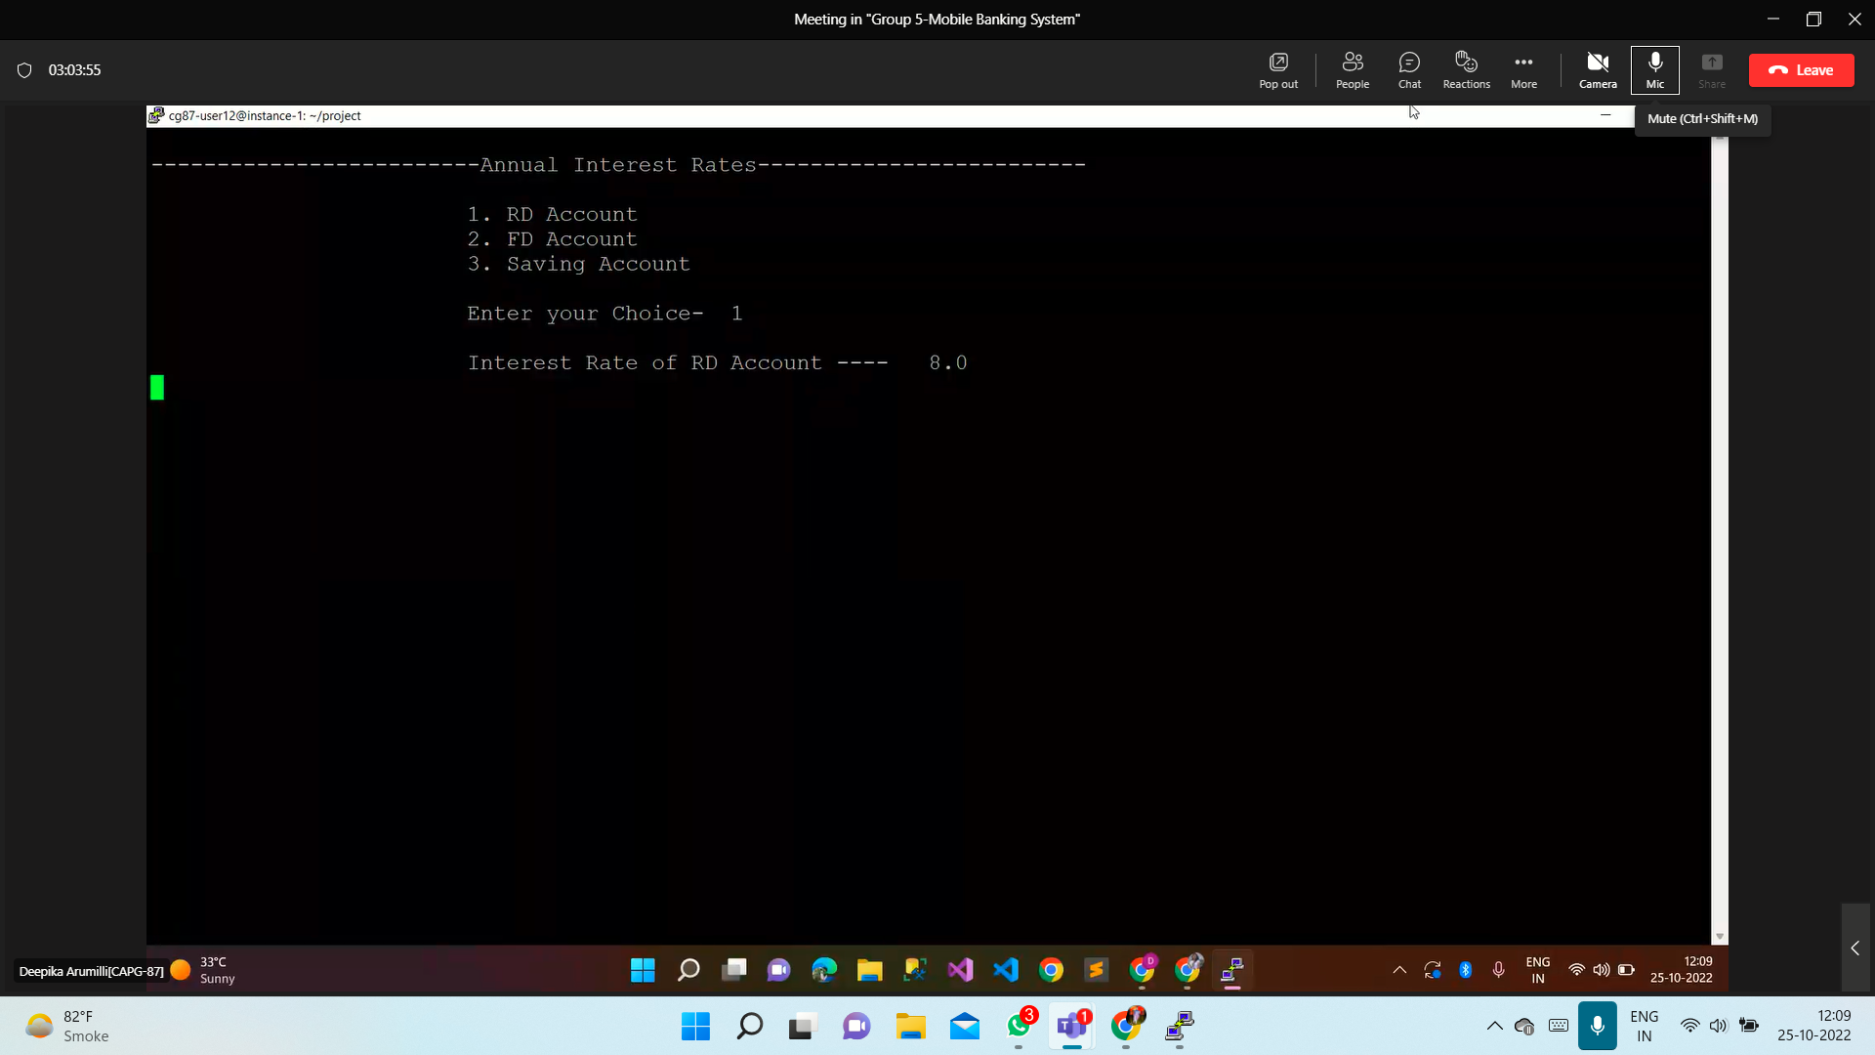

**Choice 4.2:**

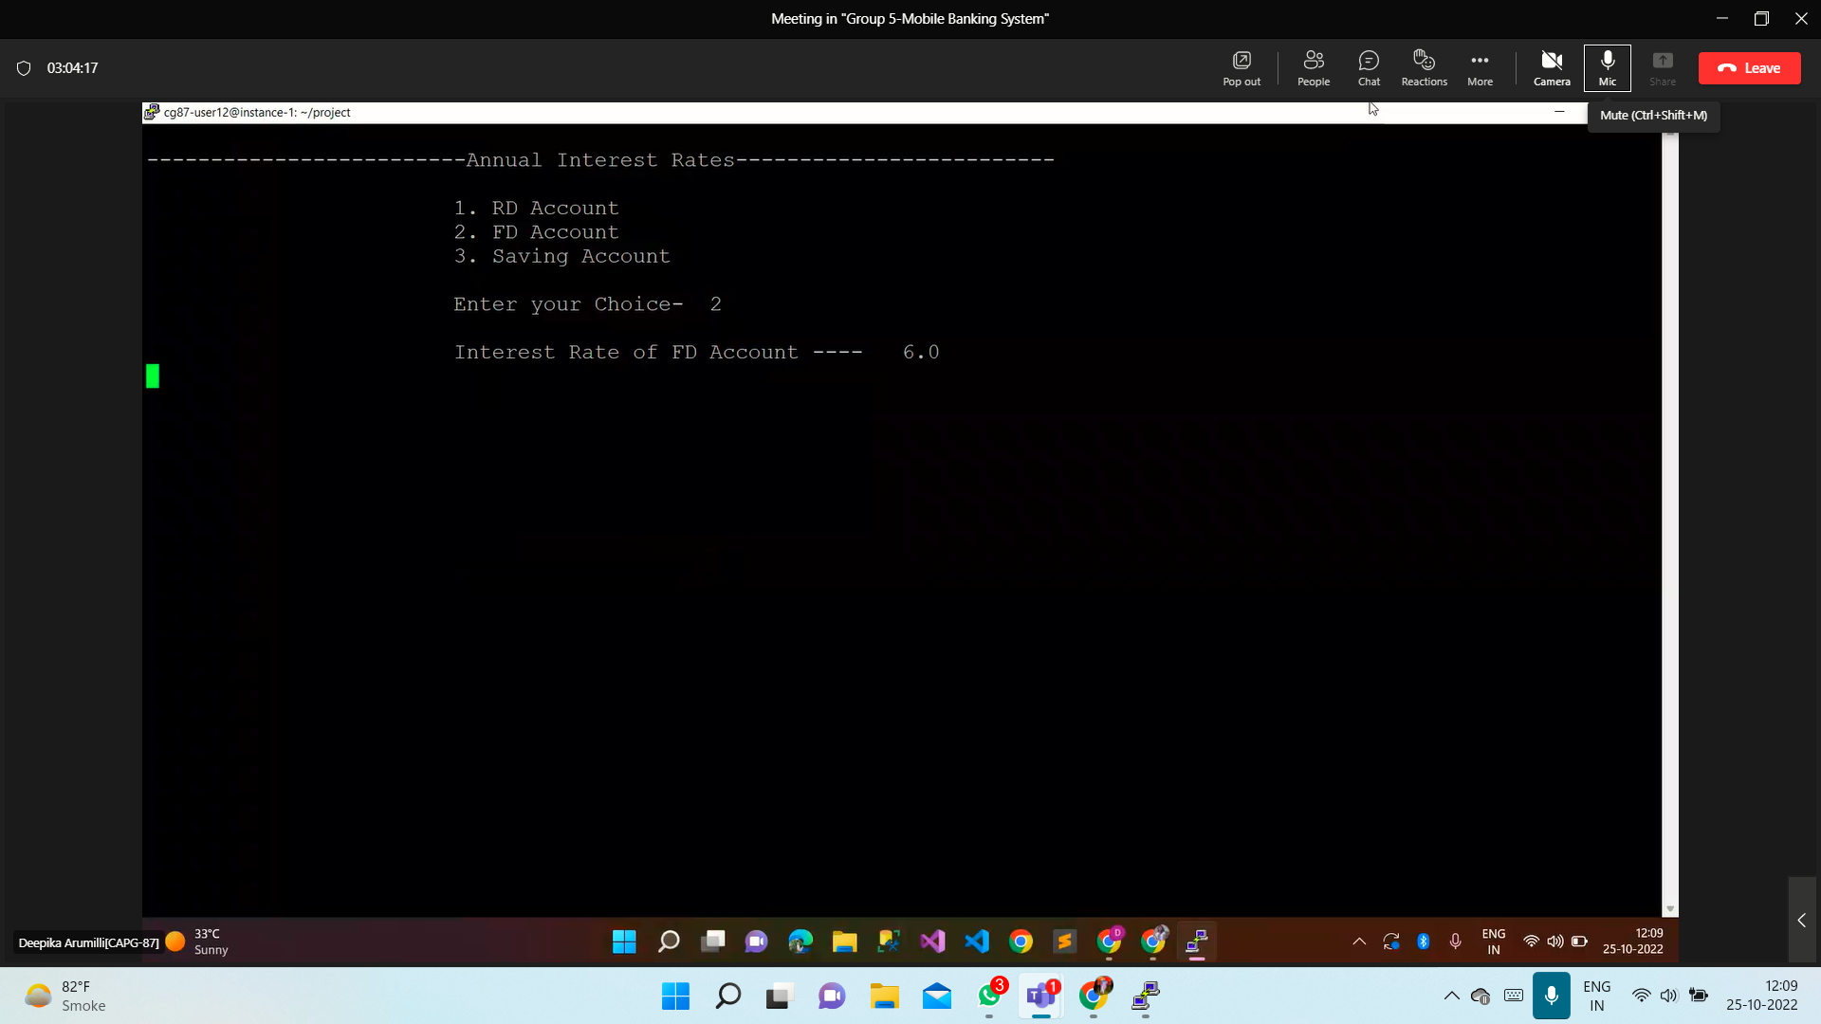

**Choice 4.3:**

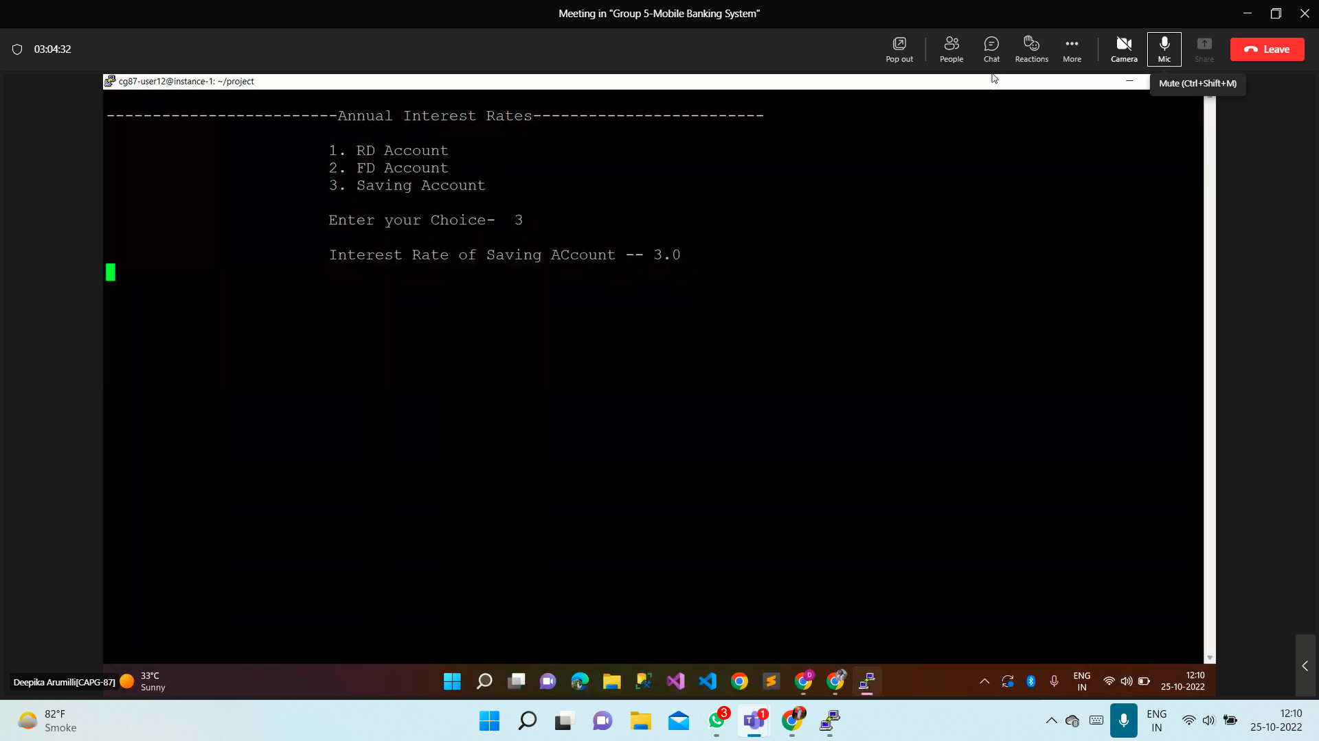

**test_case-12->close_rd_account**

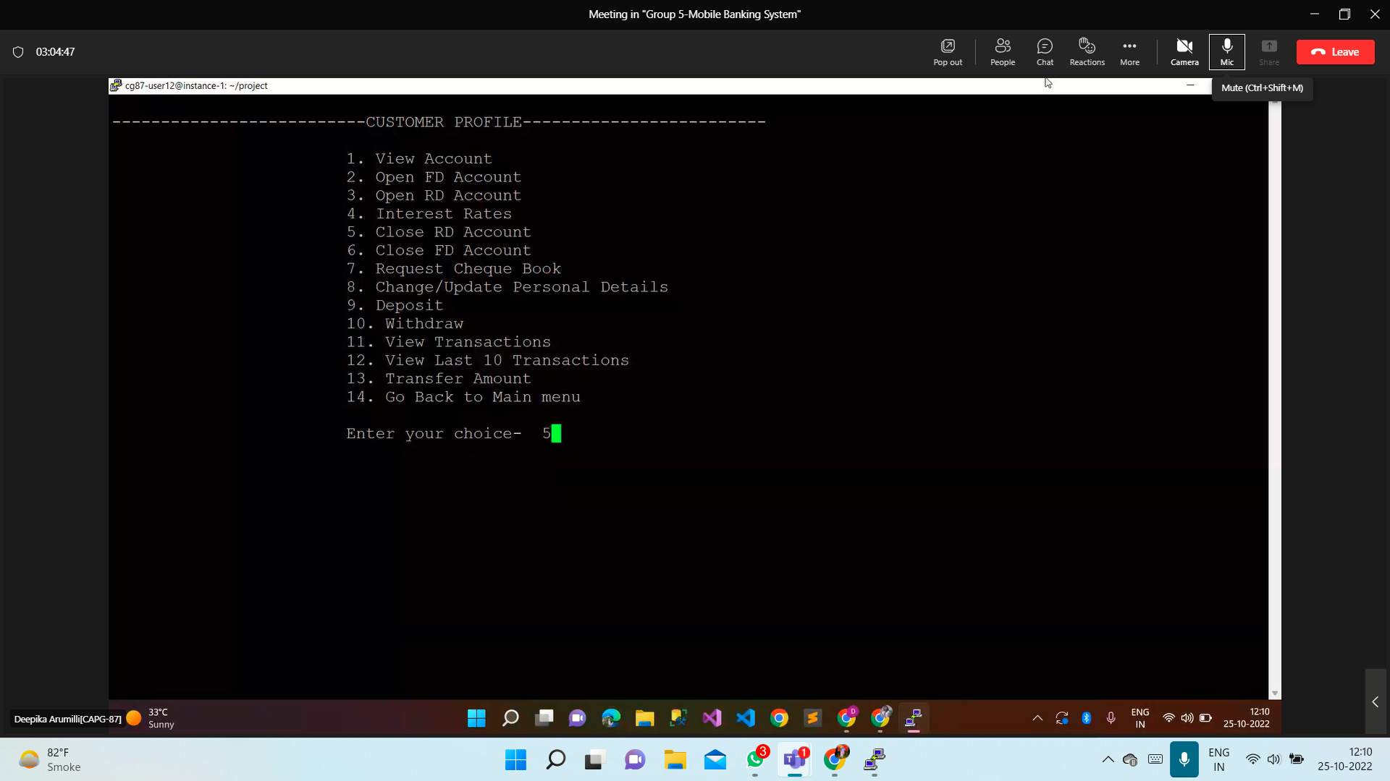

**Output:**

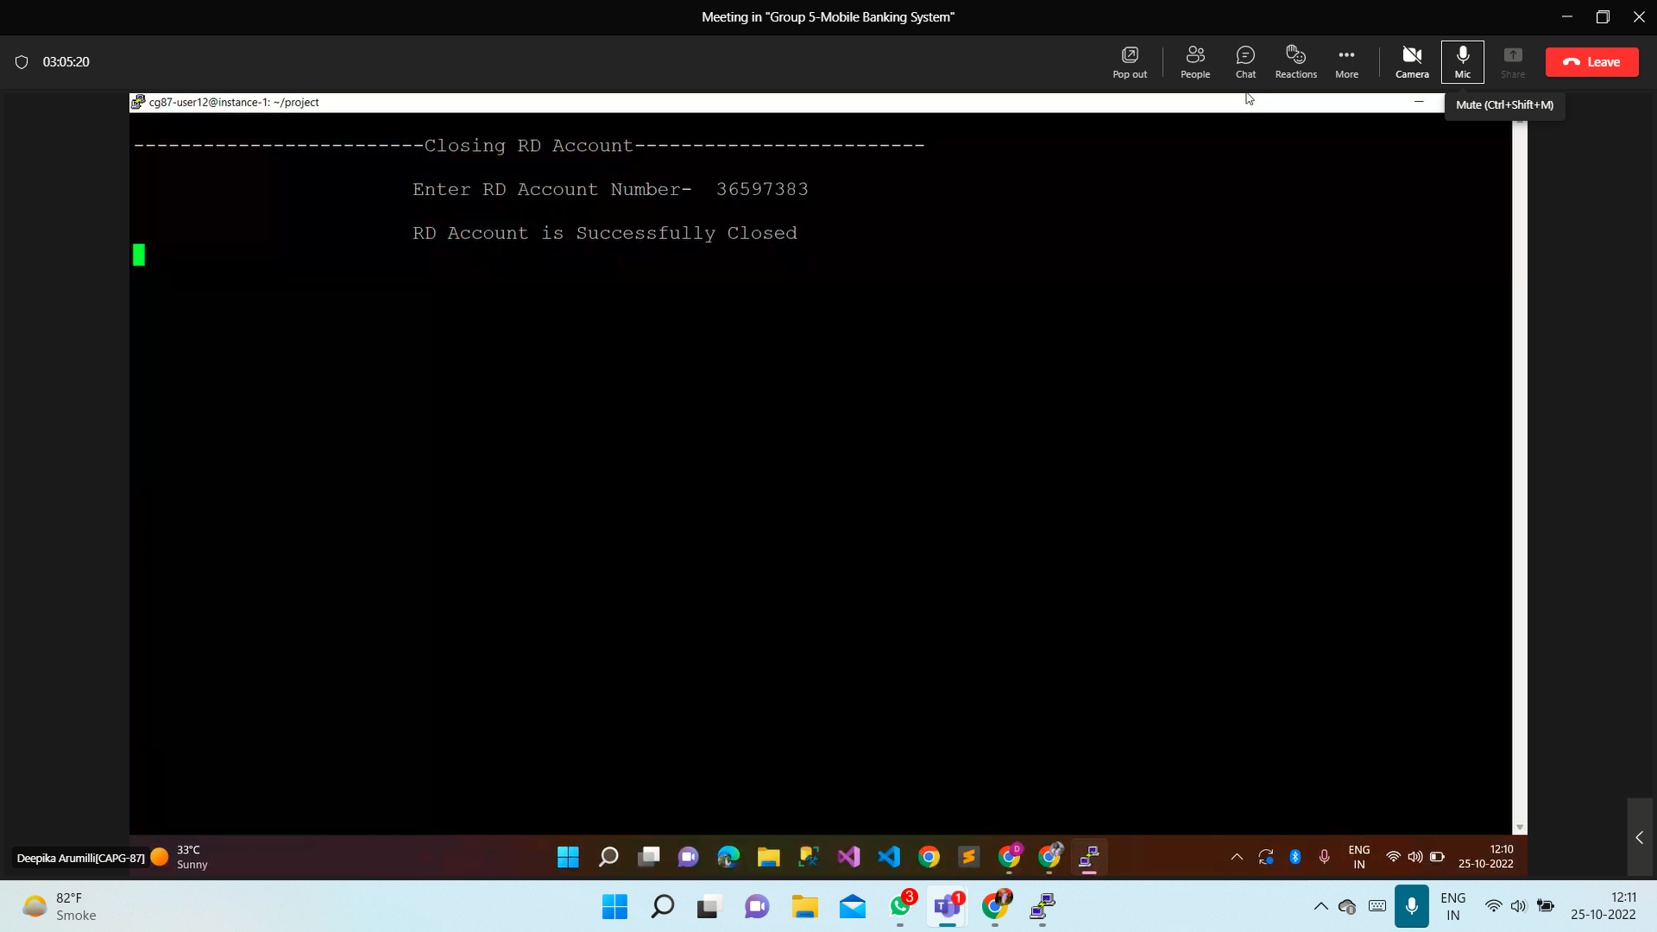

**test_case-13->close_fd_account**

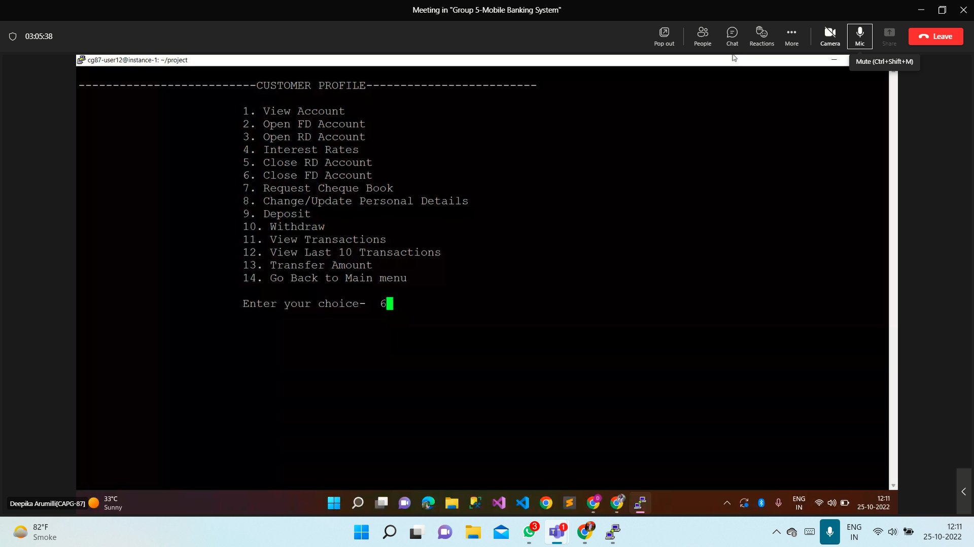

**Output:**

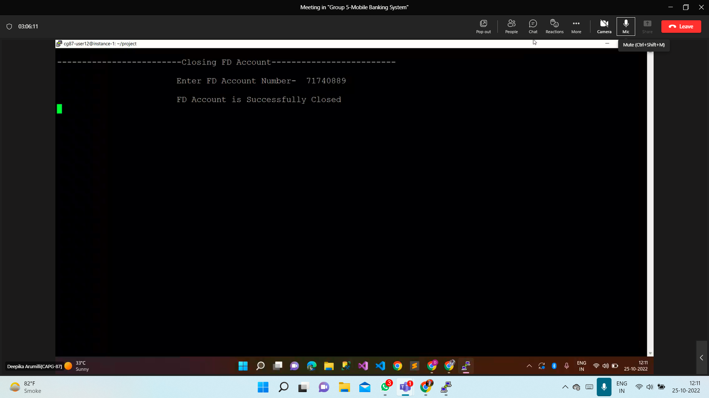

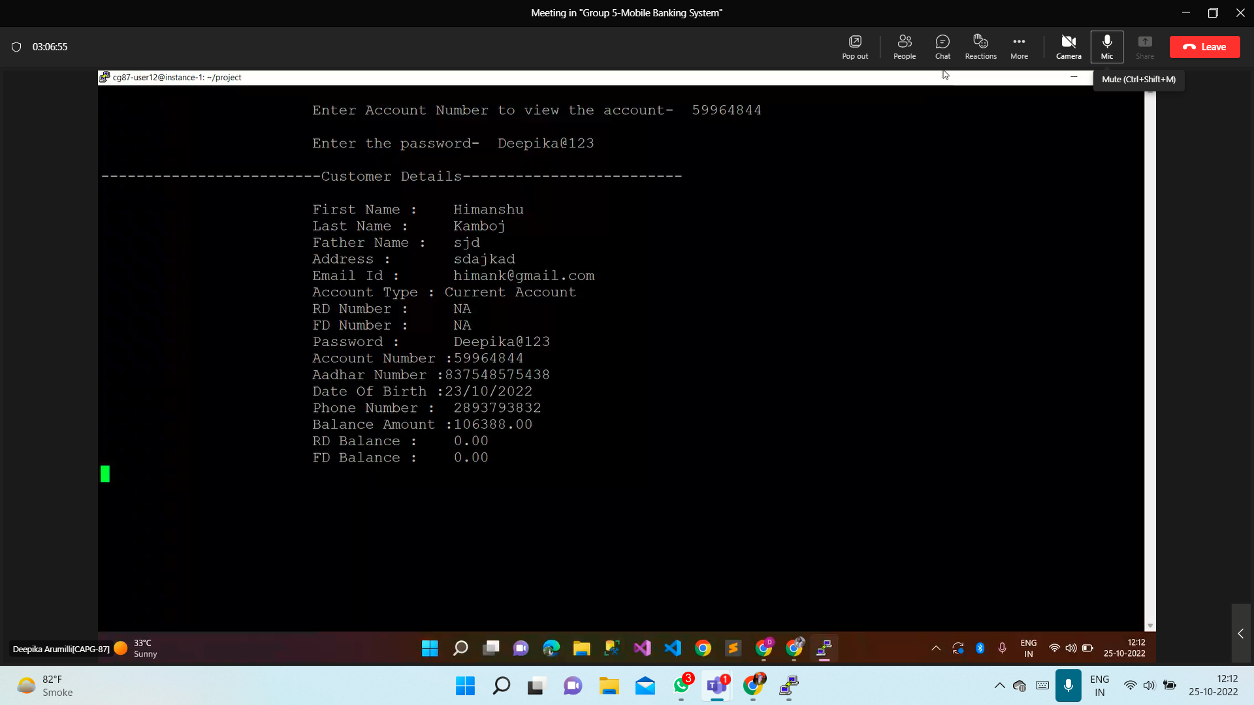

**test_case-14->request_chequebook**

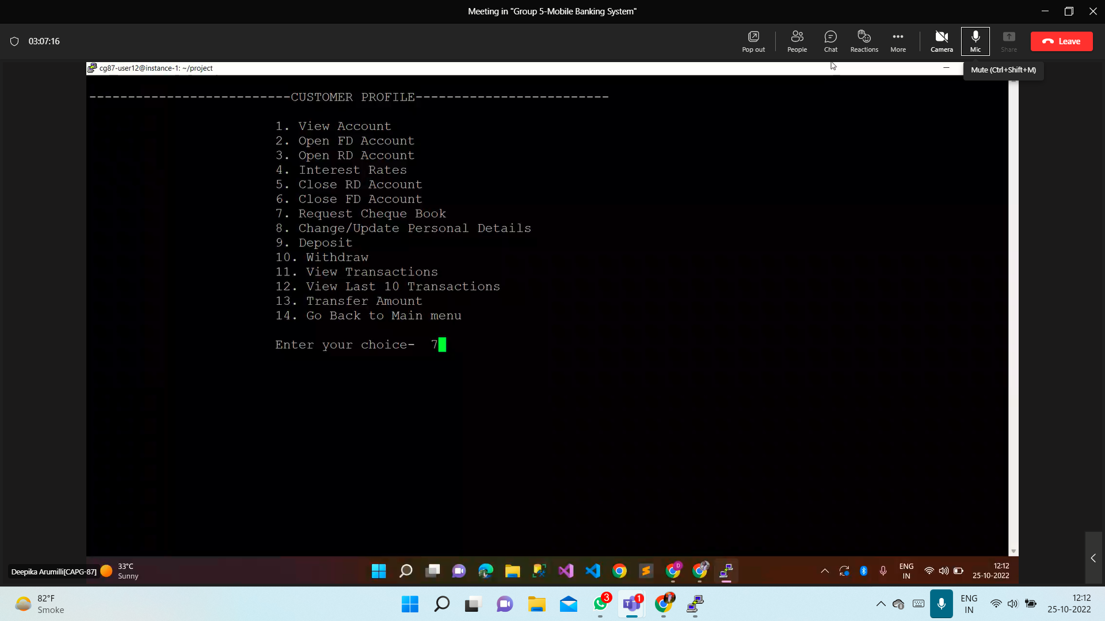

Output:

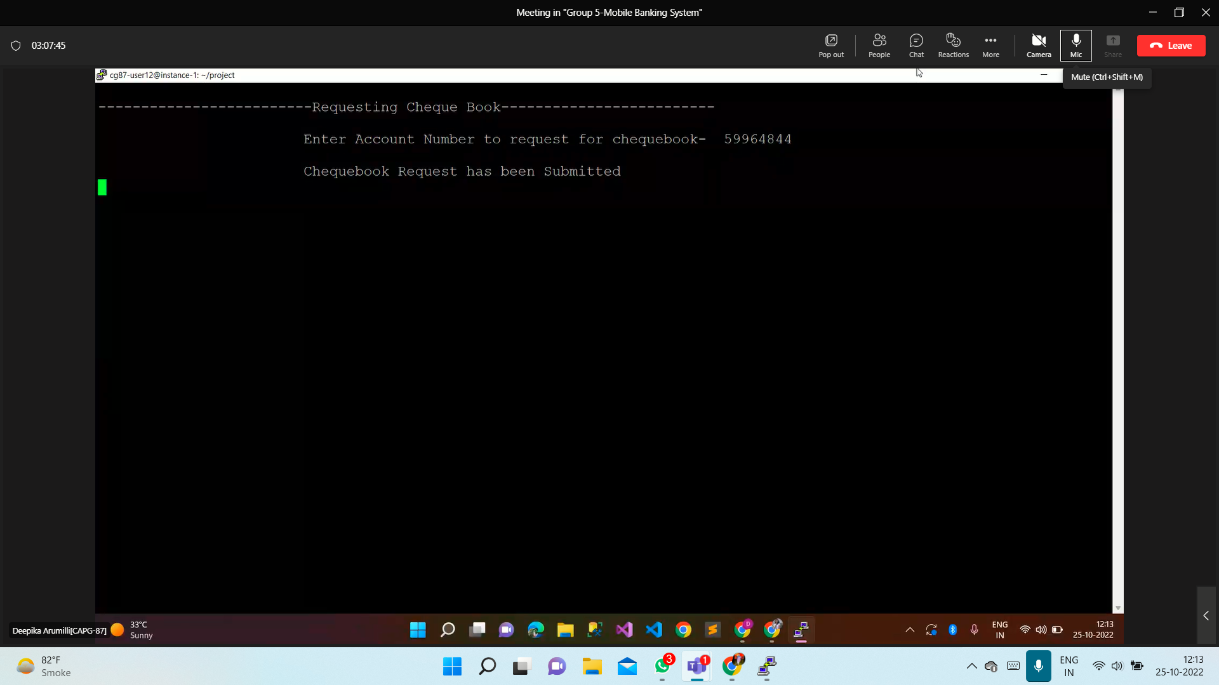

**test_case-15->update_personal_details**

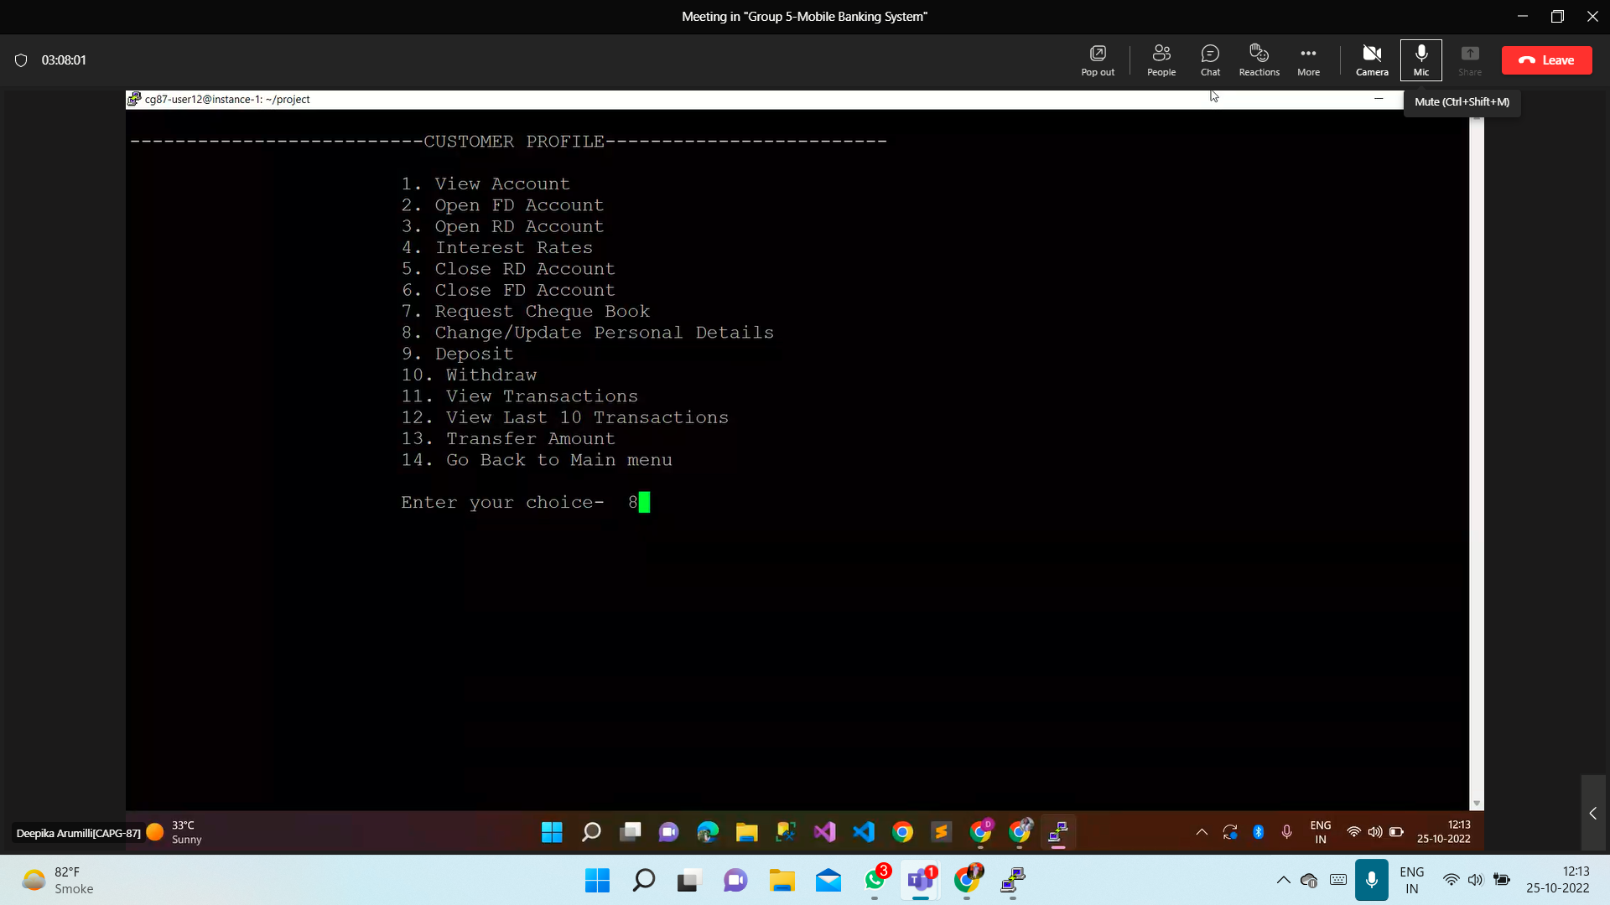

**Output:**

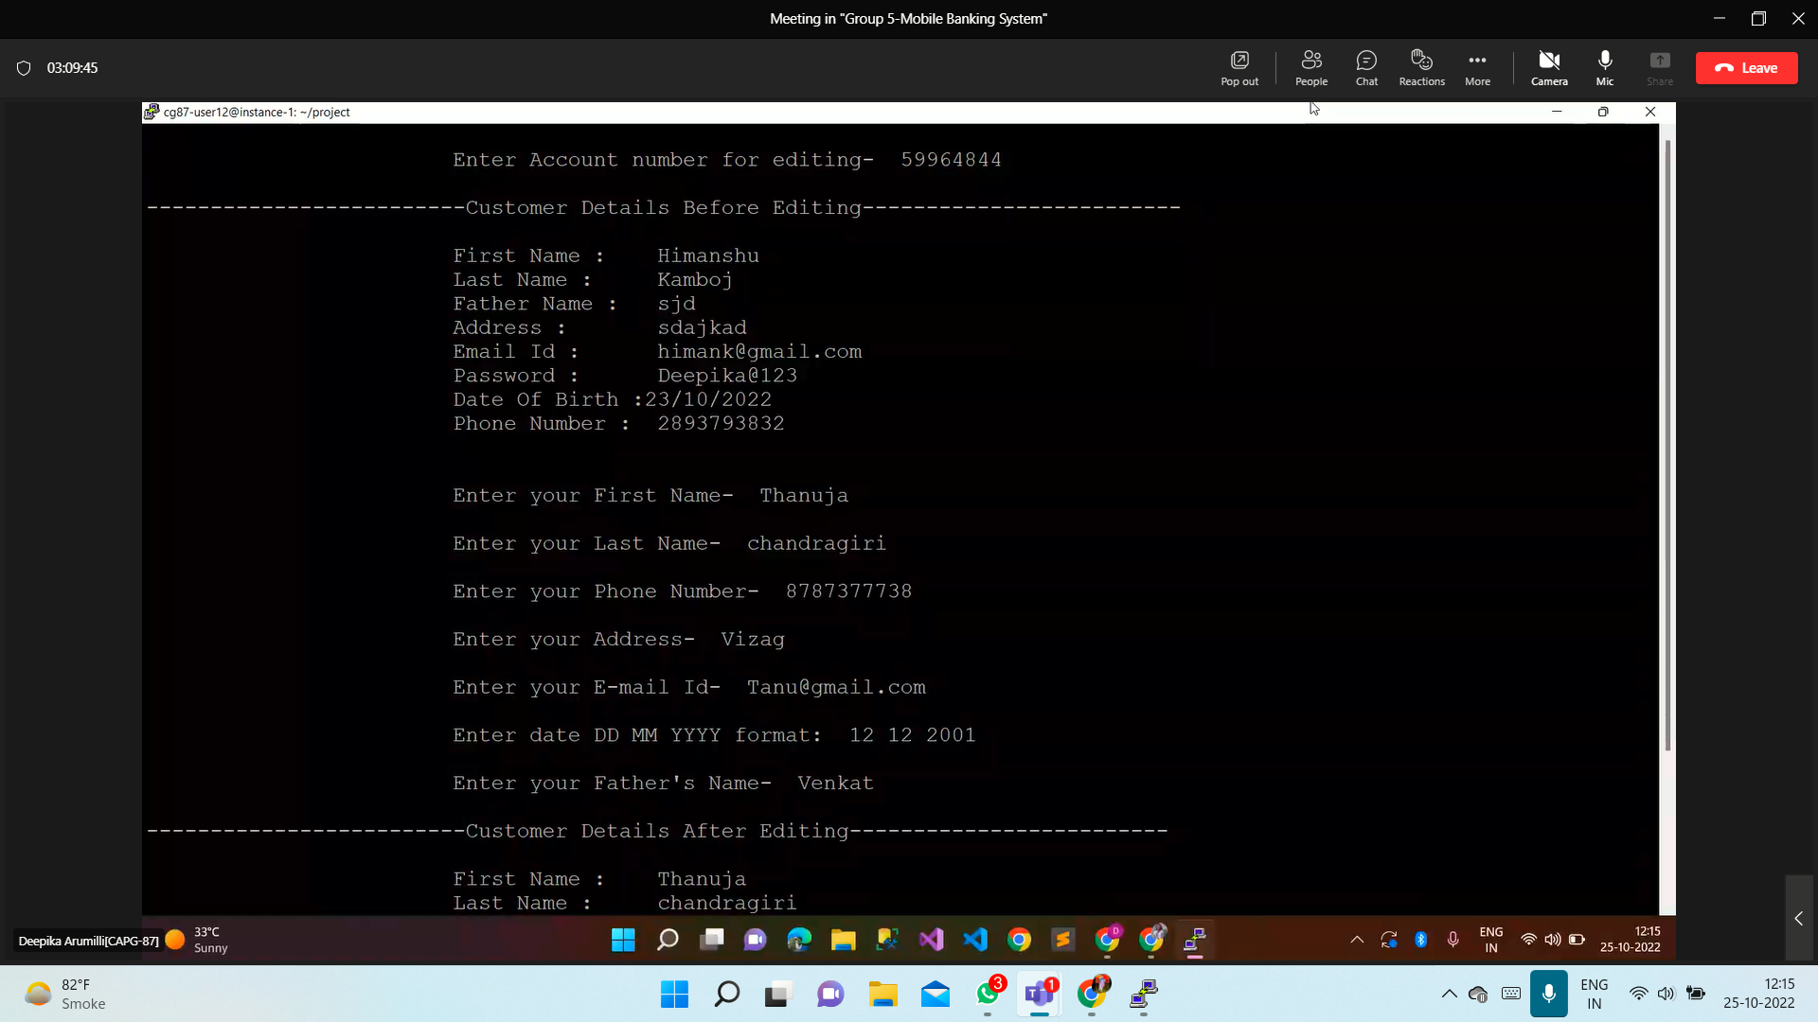

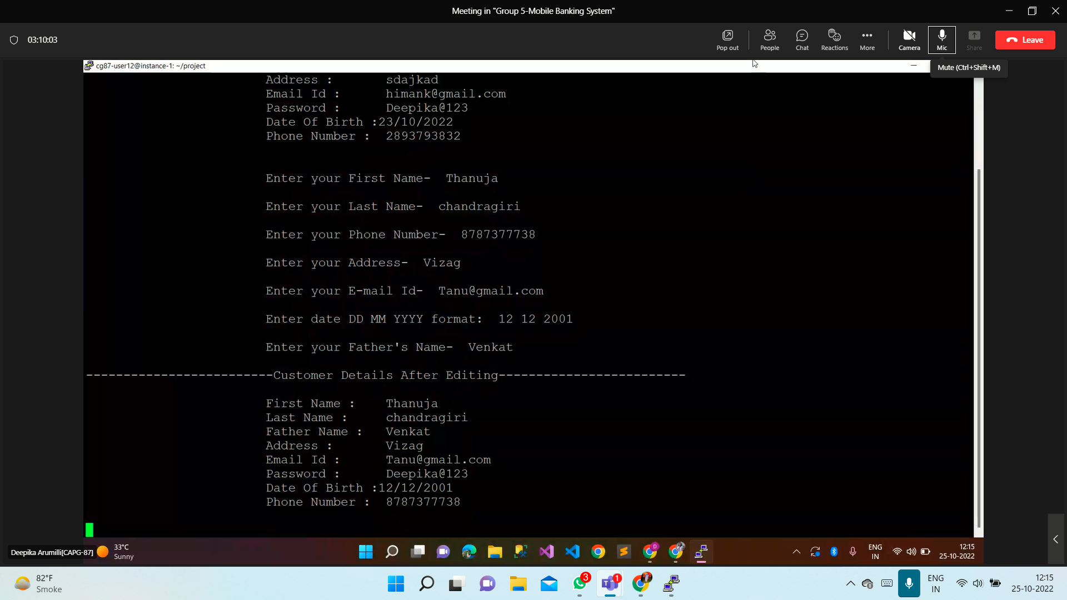

**test_case-016->deposit**

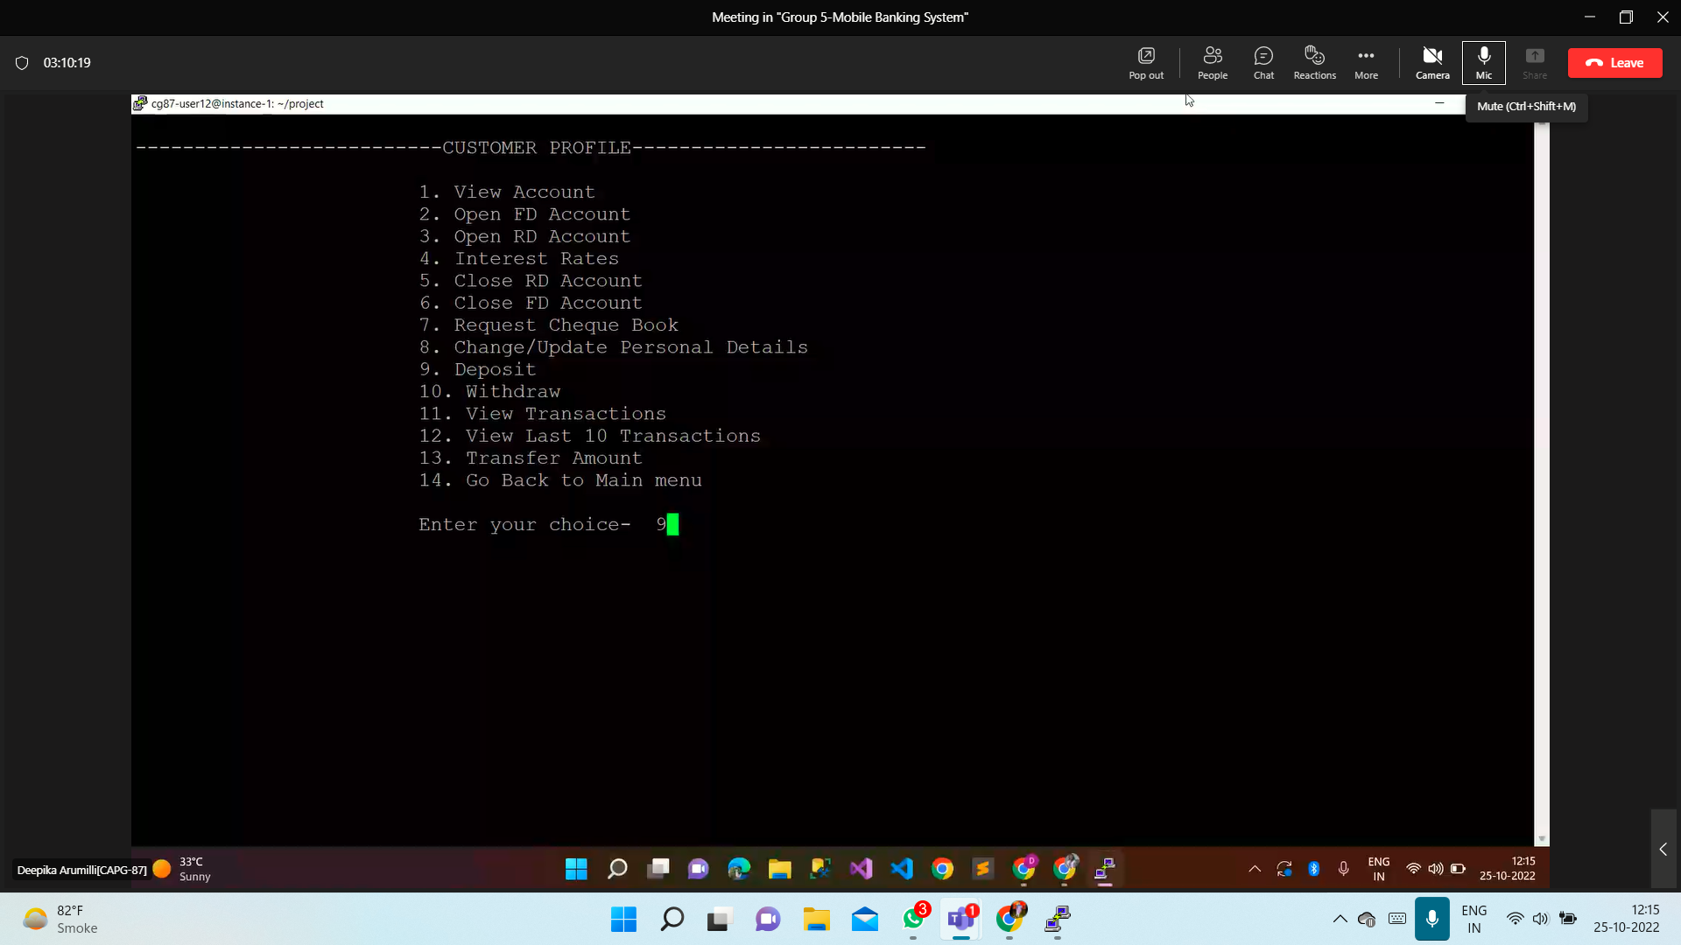

**Output:**

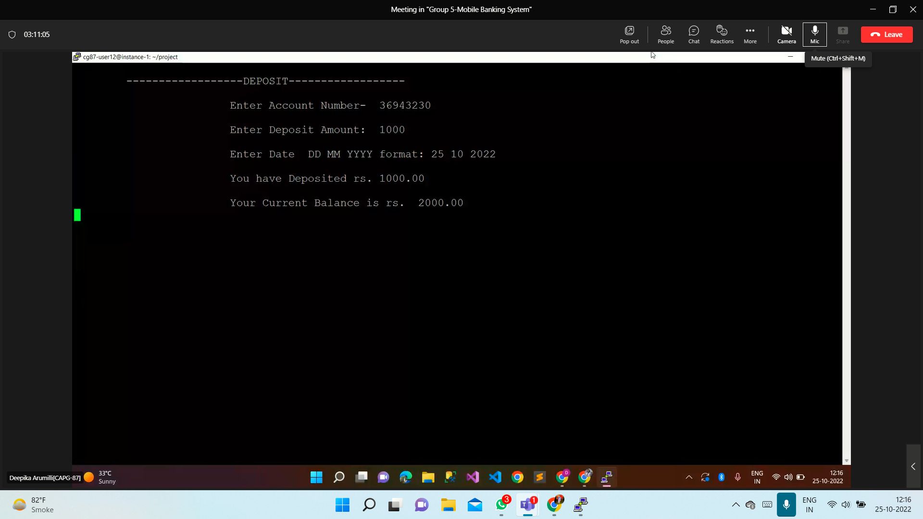

**test_case-16->withdraw**

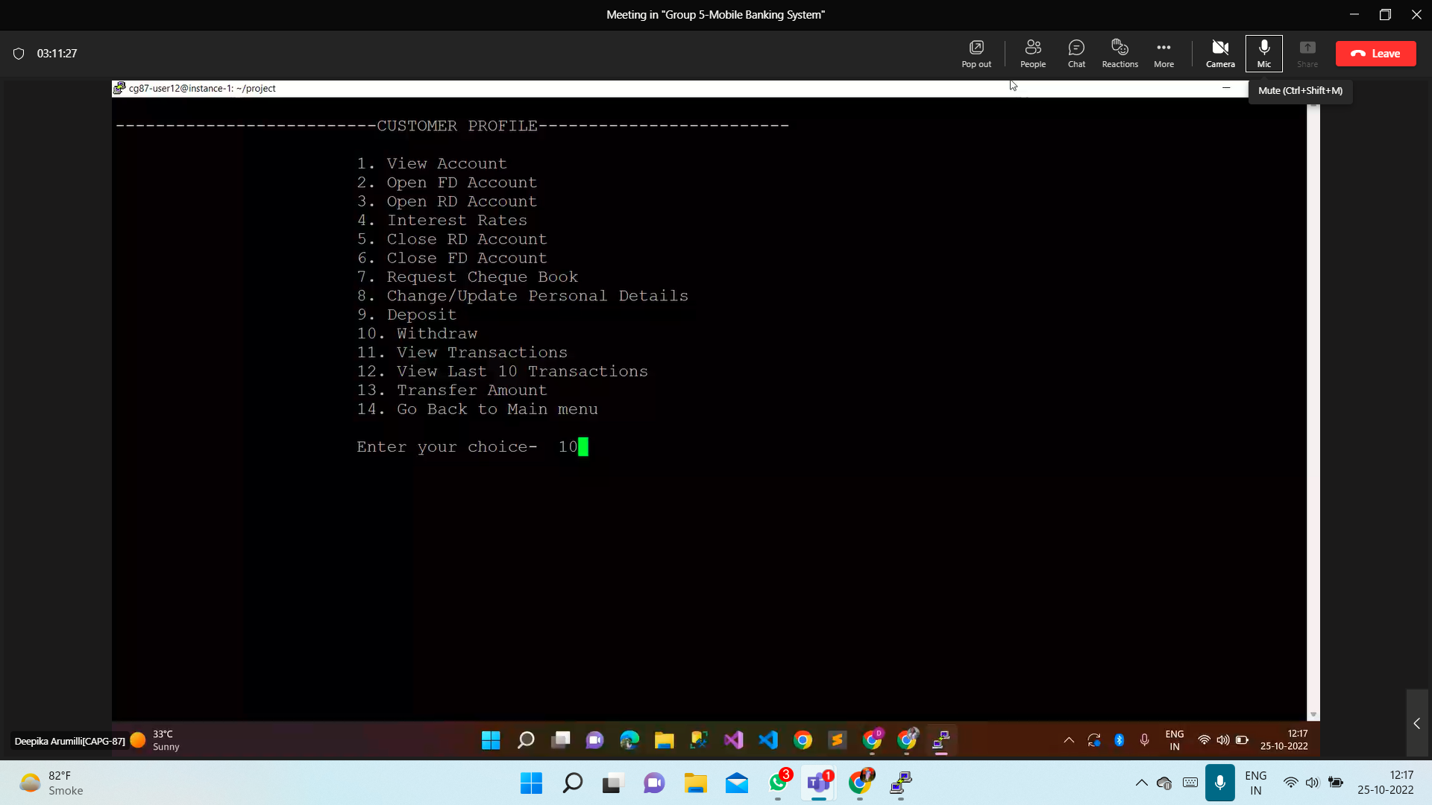

**Output:**

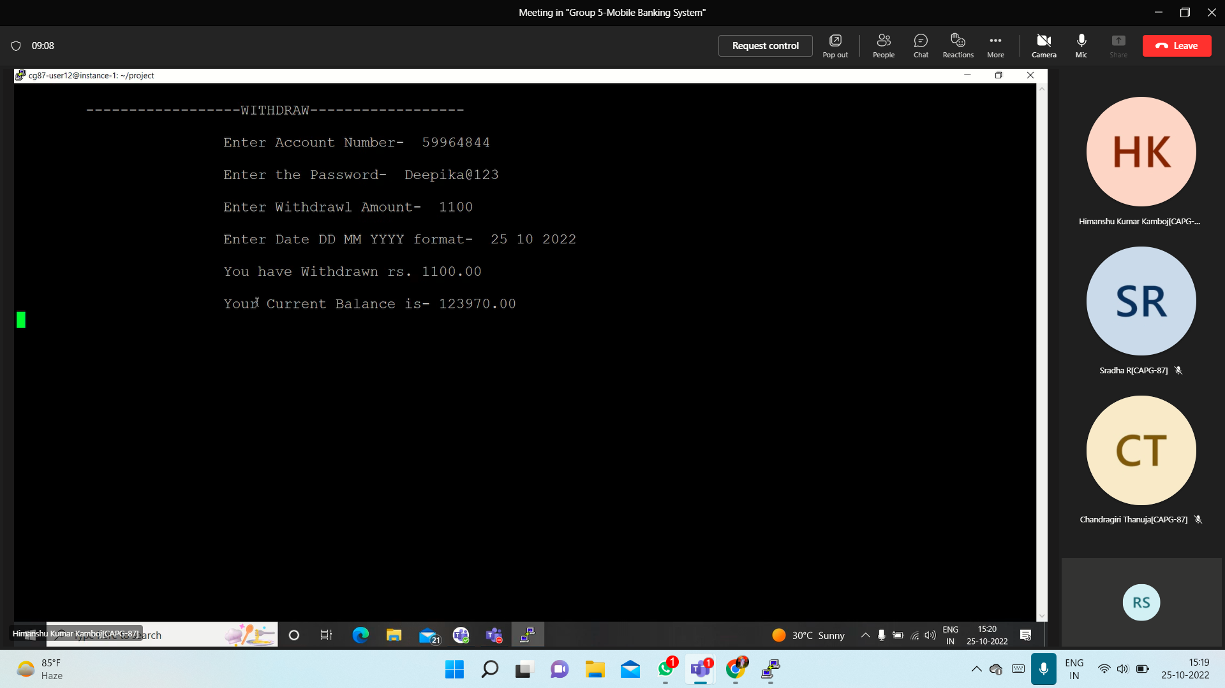

**test_case-17->view_transaction**

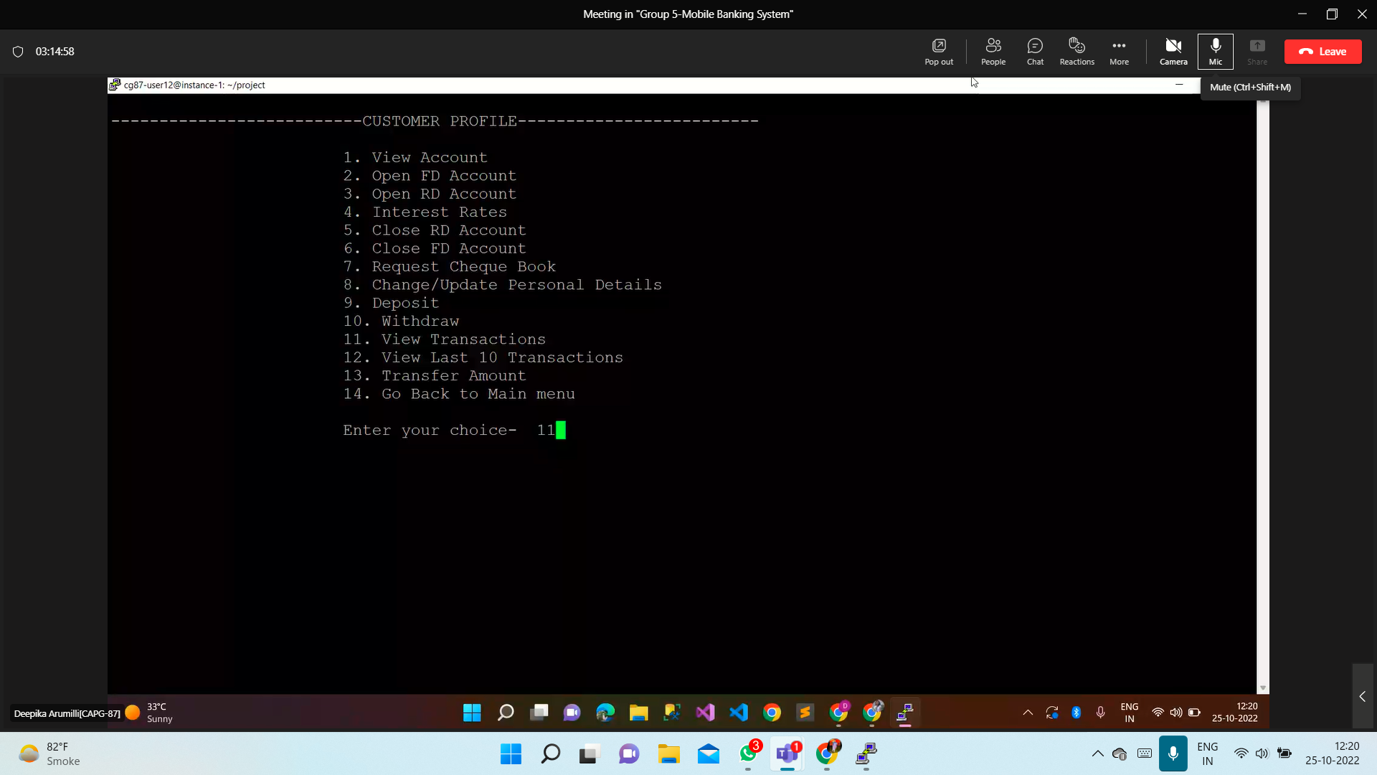

**Output:**

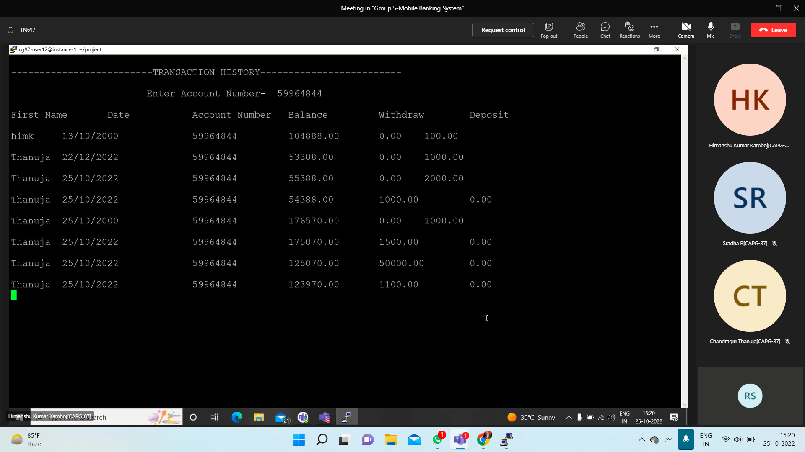

**test_case-18->last_10_transaction**

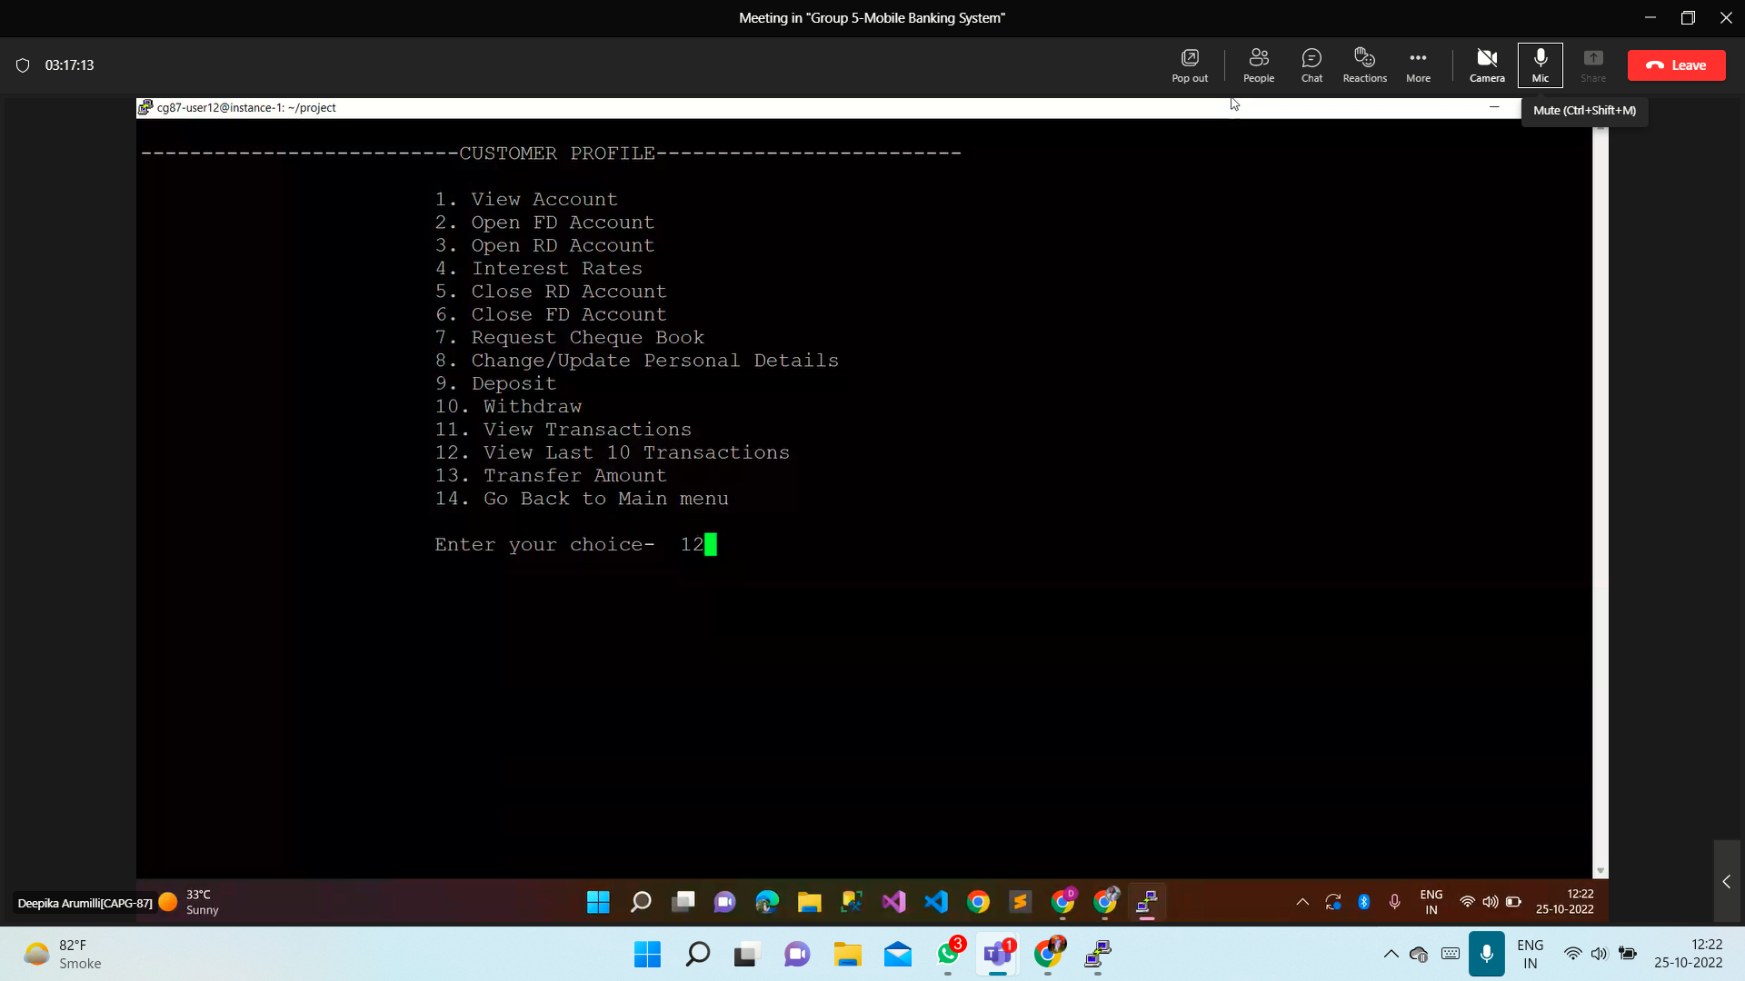

**Output:**

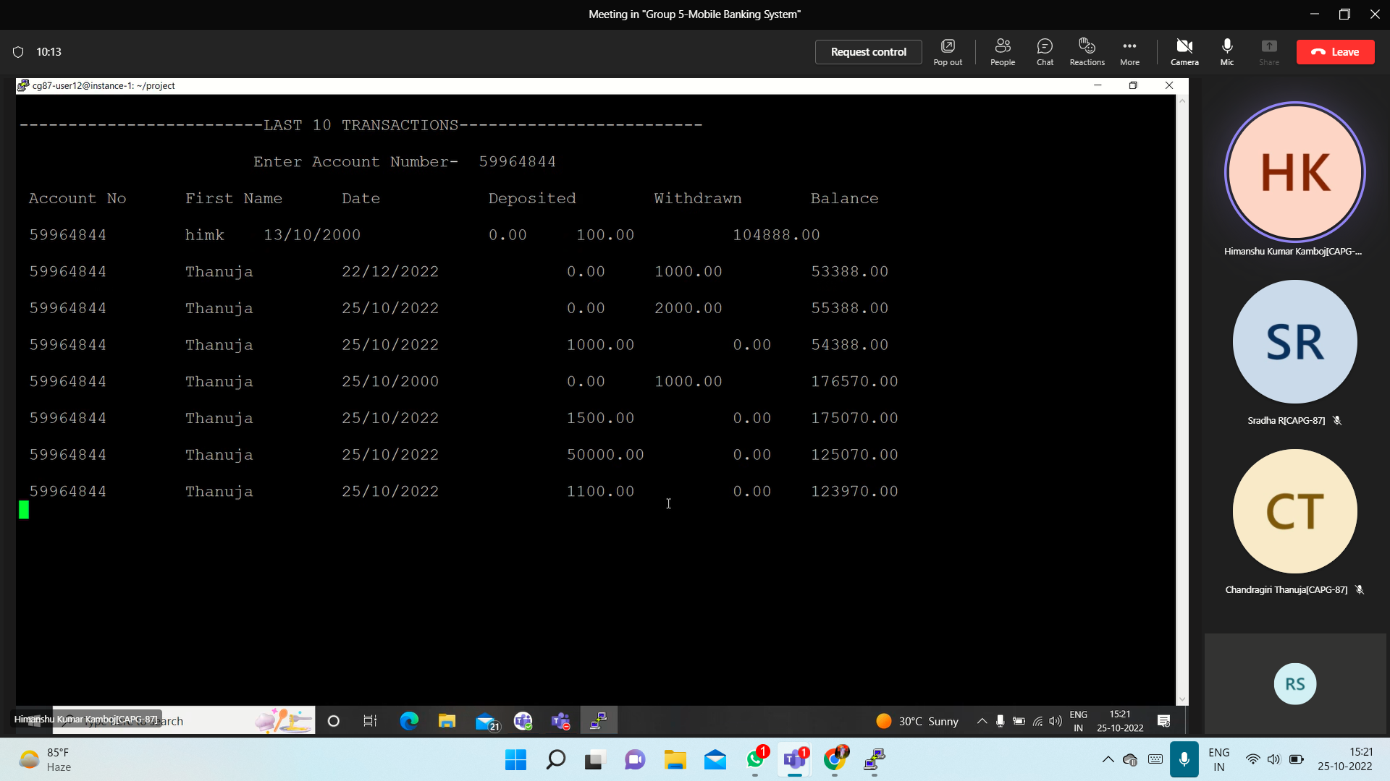

**test_case-19->transfer_funds**

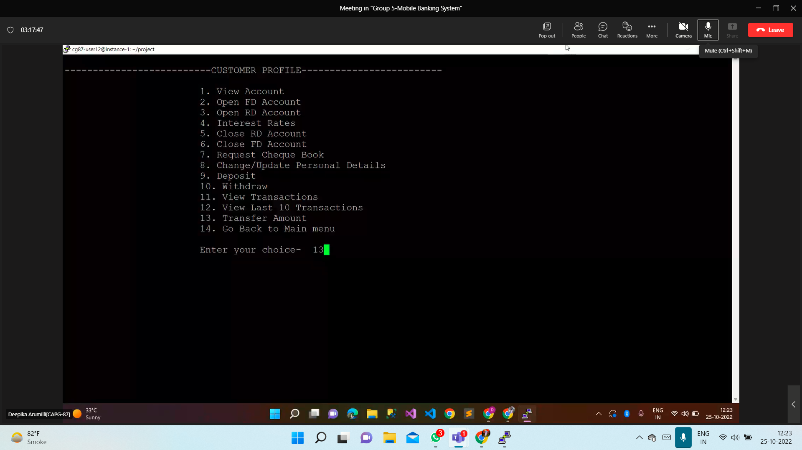

**Output:**

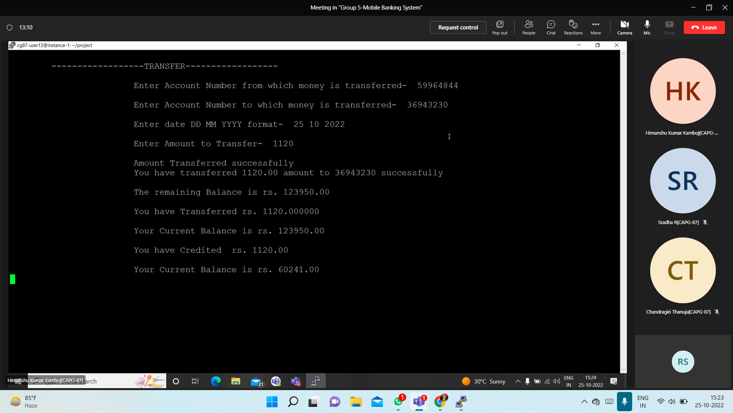

**Choice 14**

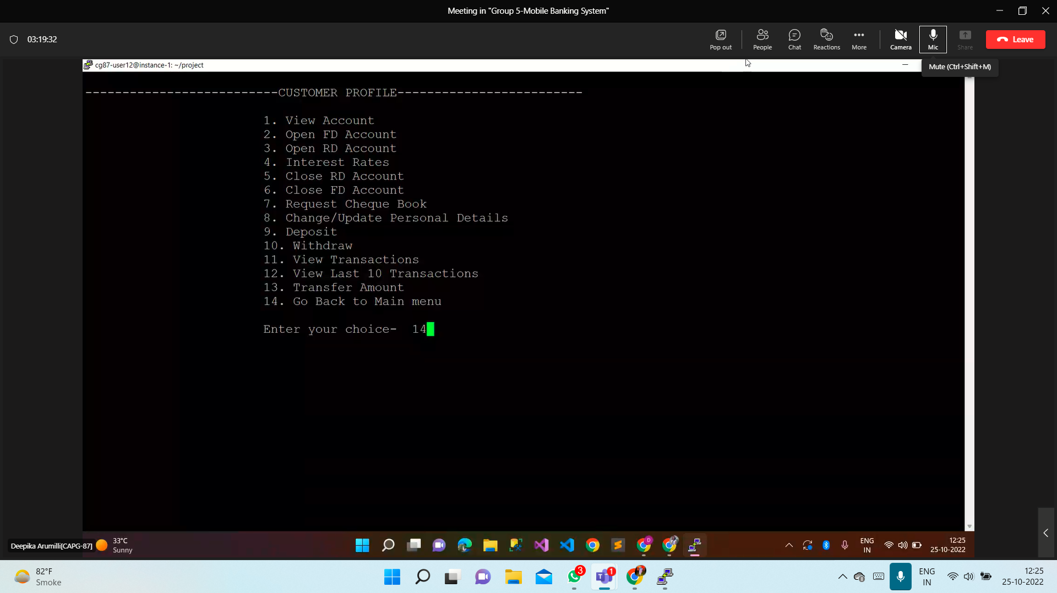

**C- User registration**

**test_case-20->new_user_registration**

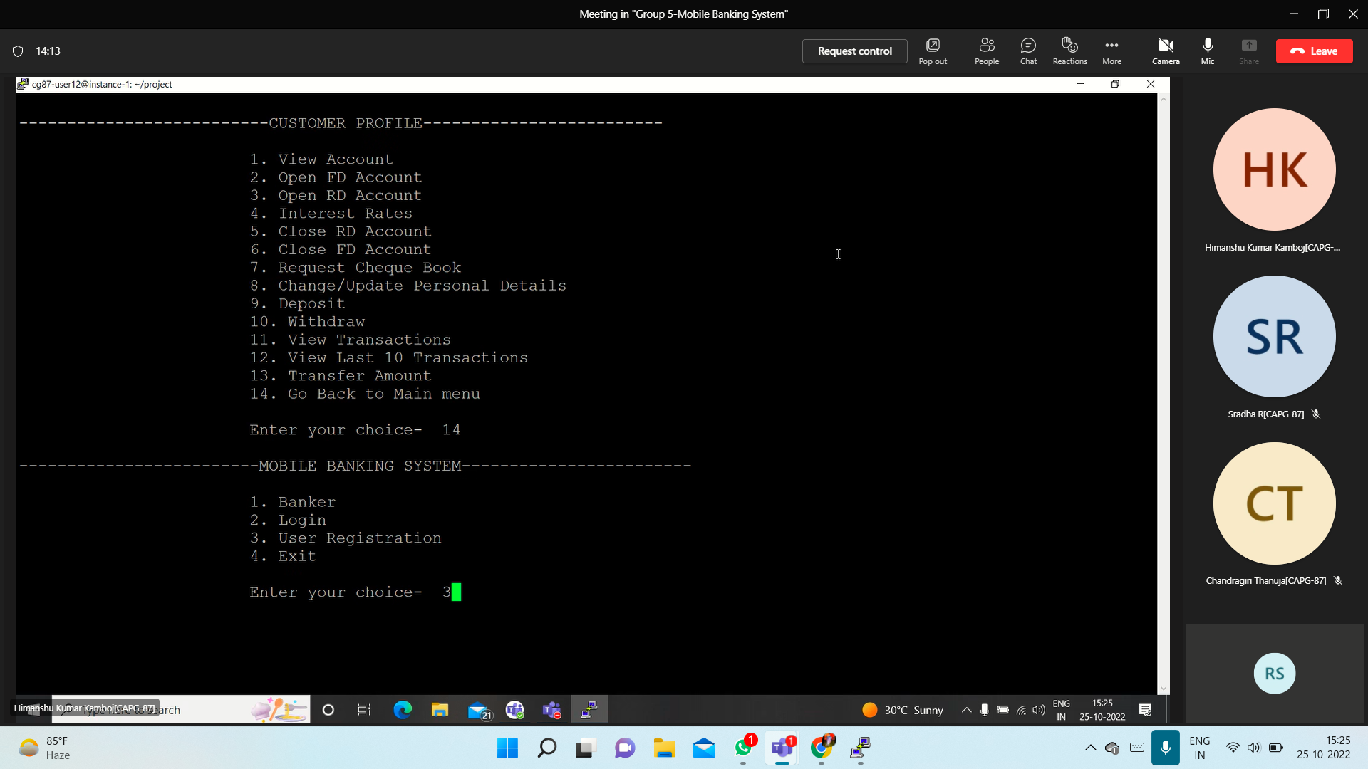

**Output:**

